**M.E. (Water Resources and Hydraulic Engineering)**

**Course affiliated to Faculty of Engineering and Technology Jadavpur University,**

**Kolkata – 700032, India**

**Certificate of Recommendation**

This is to certify that the thesis entitled ***“ASSESSMENT OF GROUNDWATER POTENTIAL ZONE WITH INTEGRATED MCDM MODEL AND WQI IN SILABATI-JOYPANDA RIVER BASIN OF WEST BENGAL”*** is bonafide work carried out by **SAYAK KARMAKAR** under our supervision and guidance for partial fulfilment of the requirements for the Post Graduate degree of Master of Engineering in Water Resources & Hydraulic Engineering during the academic session 2020-2022 in the department of School of Water Resources Engineering, Jadavpur University, Kolkata – 700032.

***DIRECTOR***

|  |  |  |
| --- | --- | --- |
| **Prof. (Dr.) Pankaj Kumar Roy** | |  |
| School of Water Resources | | Engineering |
| Jadavpur University  **Kolkata – 700032** | |  |
|  |
| ***THESIS ADVISOR***  **Prof. (Dr.) Pankaj Kumar Roy** School of Water Resources Engineering Jadavpur University  **Kolkata – 700032**    **Prof. (Dr.) Subenoy Chakraborty** | | |
| ***DEAN*** | | |
| Faculty of Interdisciplinary Studies, Law & | | |
| Management | | |
| Jadavpur University  **Kolkata – 700032** | | |

**M.E. (Water Resources and Hydraulic Engineering)**

**Course affiliated to Faculty of Engineering and Technology Jadavpur University,**

**Kolkata – 700032, India**

***CERTIFICATE OF APPROVAL \*\****

This foregoing thesis is hereby approved as a credible study of an Engineering subject carried out and presented satisfactorily to warrant its acceptance as a prerequisite to the degree for which it has been submitted. It is understood that by this approval, the undersigned do not endorse or approve any statement or opinion expressed or conclusion drawn therein but approve the thesis only for the purpose it has been submitted.

**Committee ____________________**

**Final Examination ____________________**

**For the evaluation**

**Of the thesis ____________________**

** Only in case the thesis is approved.

**Declaration of Originality and Compliance of Academic Ethics**

I hereby declare that this thesis contains a literature survey and original research work by the undersigned candidate, as part of my Master of Engineering degree in Water Resources & Hydraulic Engineering, Jadavpur University during the academic session 2020-22.

All information in this document has been obtained and presented in accordance with academic rules and ethical conduct.

I also declare that, as required by these rules and conduct, I have fully cited and referred all materials and results that are not original to this work.

**Name: SAYAK KARMAKAR**

**Roll No**: **M4WRE22020**

**Thesis Title**: *“****ASSESSMENT OF GROUND WATER POTENTIAL ZONE WITH INTEGRATED MCDM MODEL AND WQI IN SILABATI-JOYPANDA RIVER BASIN OF WEST BENGAL”***

**Signature:**

**Date:**

***ACKNOWLEDGEMENT***

I express my sincere gratitude to my supervisor Prof. (Dr.) **Pankaj Kumar Roy**, Director & Professor, School of Water Resources Engineering, Jadavpur University under whose supervision and guidance this work has been carried out. I am deeply indebted to him for his valuable suggestions, inspiring guidance and continuous help, which made possible the completion of the present work. It would have been impossible to carry out this thesis work with confidence without his wholehearted involvement, advice, support and constant encouragement throughout.

I also express my sincere gratitude to Prof. (Dr.) **Asis Majumdar**, SWRE, Jadavpur University; Prof. (Dr.) **Arunabha Majumder**, Professor- Emeritus, SWRE, Jadavpur University; Dr. **Rajib Das**, Assistant professor, SWRE, Jadavpur University, Dr. **Subhasish Das**, Assistant Professor, SWRE, Jadavpur University; Dr. **Gourab Banerjee**, Assistant Professor, SWRE, Jadavpur University for their valuable suggestions.

I would like to express my special thanks to Miss **Sudipa Halder**, senior research scholar, SWRE, JU for her continuous help and support throughout the thesis work. I would also like to thank Swetasree Nag, Saurabh Kumar Basak, Bishal Ghosh, Priyabrata Mondal, Poulami Ray, Devdas Chowdhury, and Shilpa Saha, my seniors in SWRE, JU for their valuable suggestions.

I wish to express my gratefulness to my batch mates Pratik and Sankalita and my junior Abhishek for their help and encouragement.

Thanks are also due to all the faculties and staffs of School of Water Resources Engineering Jadavpur University for their direct and indirect help and support.

**Date: *SAYAK KARMAKAR***

**Place: JADAVPUR UNIVERSITY Roll No.: M4WRE22020**

**Table of Contents**

1 Chapter: Introduction 1

1.1 Literature Review 1

1.2 Research Gap 3

1.3 Objectives of the study 4

2 Chapter: Materials and Methodology 5

2.1 Study Area 5

2.2 Data sources and Preparation of Parameter Maps 6

2.3 Sample collection and laboratory experiments 7

2.4 Analytical Hierarchy Process 8

2.4.1 What is AHP? 8

2.4.2 Assigning Weight for Different Surface and Sub-surface Parameters 10

2.4.3 Weights for Different Sub-Criteria 14

2.5 Validation of the Model 18

2.5.1 Resistivity Survey 18

2.5.2 Validation Using Pearson’s Correlation Coefficient 21

2.6 Water Quality Assessment 21

2.6.1 Water Quality Descriptions & Test Procedures 22

2.6.2 Water Quality Index 25

3 Chapter: Concepts & Criteria 28

3.1 Descriptions of different thematic layers 28

3.1.1 Drainage Density 28

3.1.2 Geology 28

3.1.3 Geomorphology 31

3.1.4 Land Use and Land Cover 31

3.1.5 Distance from Lineaments 31

3.1.6 Porosity of Soil 31

3.1.7 Runoff 34

3.1.8 Rainfall 38

3.1.9 Soil Class 38

3.1.10 Distance from Wells 38

3.1.11 Relative relief 38

3.1.12 Permeability or Hydraulic Conductivity 41

3.1.13 Slope 51

3.1.14 Water Holding Capacity 51

3.2 Other Soil Tests 54

3.2.1 Specific Gravity Test 54

3.2.2 Moisture Content 57

3.2.3 Bulk Density and Dry Density 58

4 Chapter: Results and Discussions 60

4.1 Delineation of Groundwater Potential Zone 60

4.2 Water Quality Assessment 61

5 Chapter: Validation of the Model 67

5.1 Validation Using Pearson’s Correlation Coefficient 67

5.2 Validation Using VES Survey 68

6 Chapter: Conclusions 71

6.1 Overview 71

6.2 Recommendation 71

6.3 Future considerations 72

6.4 Limitations 72

7 References 73

***List of Figures***

*Figure 1 Study Area Map* 6

*Figure 2 Process flow of Analytical Hierarchy Process* 9

*Figure 3 Direction of current flow lines and equipotential lines in Schumberger arrangement* 19

*Figure 4 Vertical Electrical Sounding survey in the field* 19

Figure 5 *Probe to measure pH, TDS & EC* 22

*Figure 6 Spectrophotometer DR 2800 (SO42-, PO43- &NO3* -) *Figure 7 Spectroquant Pharo 300* 25

*Figure 8 Methodology of the thesis work* 27

Figure 9 *Drainage Density map of the study area* 29

*Figure 10 Geology map of the study area* 29

*Figure 11 Geomorphology map of the study area* 30

*Figure 12 Land use and land cover map of the study area* 30

*Figure 13 Distance from lineament map of the study area* 33

*Figure 14 Porosity map of the study area* 33

*Figure 15 Runoff map of the basin* 34

*Figure 16 Process flow of runoff calculation by SCS curve number method* 35

*Figure 17 Rainfall map of the study area* 39

*Figure 18 Soil map of the study area* 39

*Figure 19 Distance from the wells map of the study area* 40

*Figure 20 Relative relief map of the study area* 40

*Figure 21 Permeability or hydraulic conductivity map of the study area* 42

*Figure 22 Soil classification according to grain size* 45

*Figure 23 Graphs of Permeability values by empirical formulas by different soil types* 50

*Figure 24 Slope map of the study area* 53

*Figure 25 Water holding capacity map of the study area* 53

*Figure 26 Specific gravity test arrangement in laboratory* 55

*Figure 27 Field level bulk density determination using core-cutter* 55

Figure 28 Determination of bulk density by water displacement method 59

*Figure 29 Groundwater potential zone map of the study area* 60

*Figure 30 Percentage area for each potential class for Silabati and Joypanda basin* 61

*Figure 31 Comparative Presentations of Water Quality Parameters for different sites* 65

*Figure 32 Comparative representation of WQI values of different sites* 66

Figure 33 *Water level vs Groundwater potential Index graph* 67

Figure 34 *Apparent resistivity vs half of distance between current electrodes graphs* 68

***List of Tables***

*Table 1* *Locations of the soil and water sampling sites* 8

*Table 2 Scale of Relative Importance* 10

*Table 3 Pairwise Comparison Matrix* 11

*Table 4 Normalized Pairwise Comparison Matrix* 12

*Table 5 Consistency Matrix* 13

*Table 6 Random Index values* 14

*Table 7 Criteria Weights for Sub-parameters* 15

*Table 8 Resistivity values for different subsurface materials* 18

Table 9 *Longitudinal conductance vs Rating of protective capacity* 20

*Table 10 Drinking water quality standards as per IS 10500:2012* 21

*Table 11 Pillow powders used for Sulphate, Phosphate and Nitrate test* 24

*Table 12 WQI value vs water quality status* 26

*Table 13 Porosity of the soil samples* 32

*Table 14 Runoff calculation of Joypanda Basin* 36

*Table 15 Runoff calculation for Silabati river basin* 37

*Table 16 Empirical formulas for permeability calculation* 43

*Table 17 Gradation characteristics of soil samples* 46

*Table 18 Permeability values of soil samples by different empirical equations* 47

*Table 19 Average permeability values* 48

*Table 20 Water holding capacity of the soil samples* 52

*Table 21 Specific gravity test results of the soil samples* 56

*Table 22 Grain specific gravity for different soil types* 57

*Table 23 moisture content values of the soil samples* 58

Table 24 Bulk density & dry density values of the soil samples 59

*Table 25 General water quality parameters and water quality index values* 62

*Table 26 Validation of groundwater potential using Dar-Zarrouk parameters* 69

***Abstract***

Groundwater is one of the world's most important sources of fresh water. But, due to excessive extraction declination of groundwater level is being observed nowadays. Groundwater pollution is also going to be a global concern as well as in India. The present study was carried out in the upper Silabati-Joypanda basin located in Bankura, Purulia and West Medinipur districts of West Bengal state in India. The objective of the study was to find the groundwater potential zone map using the Geographical Information system (GIS), Analytical Hierarchy Process (AHP) and Remote sensing (RS) approach and to validate the same using a Geophysical survey and groundwater level data of the study area. AHP criteria weight has been calculated for fourteen parameters namely Drainage Density, Geology, Geomorphology, Land Use and Land Cover, Distance from Lineament, Porosity of soil, Runoff, Rainfall, Soil type, Distance from Wells with High Yield, Relative Relief, Permeability of soil, Slope, Water Holding Capacity. The final groundwater potential map was classified into five categories: very low potential, low potential, moderate potential, high potential, and very high potential covering 2.84%, 39.66%, 38.14%, 17.48%, and 1.87% of the total area respectively of Silabati river basin and covering 60.43%, 28.87%, 9.07%, 1.63% and 0% of the total area respectively of Joypanda river basin. The result was validated using field-based groundwater level survey data. The groundwater potential map was also validated using the Vertical Electrical Sounding Survey by Schlumberger array method. Different Soil parameters were estimated and sieve analysis was performed in the laboratory to get the soil characteristics of the basin. Groundwater samples were collected from different locations of the basin and testing of different General water Quality Parameters was performed in the laboratory. Then, Water Quality Index was estimated by the Weighted Arithmetic mean method to get a complete scenario of the subsurface water quality of the study area.

# Chapter: Introduction

Groundwater or subsurface water occurs below the surface of the earth. Groundwater originates from different sources and through different processes like infiltration, seepage from reservoirs, influent streams, artificial recharge, seepage from oceans and water trapped in sedimentary rocks. Groundwater is a very important source of drinking water in rural and urban areas. This time, around 34% of the total annual water supply is dependent on groundwater (Magesh et al. 2012). Almost 42% of groundwater is used for agricultural purposes (Roy et al. 2020). Pollution of groundwater from different agricultural pesticides and hazardous wastes from industries became a global concern. Also, overexploitation of groundwater is a reason for the gradual declination of groundwater levels in many areas. Also, for the green revolution with increased crop production, agricultural demand for groundwater increased from 312 km3/year in the 1960s to about 743 km3/year in 2000 (Halder et al.2020). The dry region where rainfall is low is completely dependent on groundwater for irrigation purposes (Roy et al. 2020)

## Literature Review

To determine the groundwater potential zone of a study area different authors adopted different techniques worldwide. Multi-criteria decision-making (MCDM) technique is one of the most reliable and popular methodologies for the study and management of groundwater. Different techniques to determine groundwater potential zones (GWPZ) like frequency ratio, random forest model, logistic regression model, certainty factor model and weighted overlay analysis were implemented by several researchers all over the world (Das et al. 2018). The Analytical Hierarchy Process (AHP) is a popular MCDM model developed by Saaty (1999). In the region where data availability is relatively poor GIS and remote sensing techniques can be effectively used to delineate the groundwater potential zone (Halder et al. 2020). The application of GIS and RS helps to increase the accuracy of this work and reduces to be biased toward a particular parameter (Behzad et al. 2018).

Siva et al. (2017) delineated groundwater potential zone in the hard rock terrain of Sengipatti using GIS and AHP model with five thematic layers namely drainage, geomorphology, land use and land cover, slope, and lithology. Data was prepared from the Geological Survey of India toposheets and IRS-IC satellite images. Arumaikkani et al. (2017) did the same for the Salem District of Tamil Nadu state in India with seven parameters namely Land use/Land cover, Slope, Drainage Density, Soil, Geology, Geomorphology and Lineament Density with GIS and RS techniques and using Fuzzy AHP model. Magesh et al. (2012) assessed the groundwater potential of Theni District, Tamil Nadu, India using RS, GIS and Multi influencing factor techniques and considered seven thematic layers viz. lithology, slope, land-use, lineament, drainage, soil, and rainfall. They used Survey of India toposheets, satellite imagery and some conventional data to generate the thematic layers using GIS. Chowdhury et al. (2014) assessed groundwater potential in West Medinipur district, West Bengal, India using GIS and RS with the AHP model considering six parameters namely lithology, landform, drainage density, recharge, soil, land slope and surface water body. Thematic layers were prepared from IRS-1D imagery and Conventional Data. Agarwal et al. (2013) delineated the groundwater potential zone of Unnao District, Uttar Pradesh, India using GIS, RS and Analytical Network Process (ANP) technique. Geology, Geomorphology, Lineament, Drainage Density, Soil, Land Use and Land Cover, Slope, Groundwater Depth, and Rainfall these nine parameters were used to prepare the final map. SOI toposheets, LANDSAT 7 and ASTER and conventional groundwater and rainfall datasets were the secondary data used. Nag et al. (2012) delineated the groundwater potential zone in Chhatna block of Bankura district, West Bengal, India using GIS and RS techniques and the weighted index overlay method was adopted to obtain the parameter weight. Nair et al. (2017) delineated the groundwater potential zone of the Ithikkara and the Kallada river basins of South Western Ghats, Kerala, India with fourteen thematic layers namely Drainage Density, Geomorphology, Slope, Lithology, Soil, Land Use/Land Cover, Lineament Density, Topographic Wetness Index, Rainfall Distribution, Roughness, Curvature, Dissection Index, Depth to Water Level and Topographic Position Index. The weightage of the factors was assigned by Weighted Overlay Analysis.

Internationally, several research works were carried out to find groundwater potential zone. Aouragh et al. (2017) assessed the groundwater potential of middle atlas plateaus, a Part of the Sebou basin located in Morocco using six surface and subsurface parameters like lithology, slope, Karst degrees, land cover, Lineament and drainage density with the help of GIS and Fuzzy logic. Behzad et al. (2018) used Rs, GIS and AHP to delineate the groundwater potential zone of the Leylia-Keynow watershed of Iran and prioritized five criteria factors viz rainfall, lineament density, lithology slope, and drainage density. Fashae et al. (2013) delineated the groundwater potential zone with an integrated GIS and remote sensing method and AHP model in crystalline basement terrain of southwest Nigeria using nine parameters (Geology, Rainfall, Geomorphology, Soil, Drainage Density, Lineament Density, Land Use, Slope and Drainage Proximity).

Some Geophysical methods are there to identify aquifers and other subsurface layers like vertical electrical sounding (VES) survey, Ground-penetrating radar (GPR), Induced polarisation (IP), Gravitational field method, etc. Generally, geophysical methods are classified into two types. The active method measures the response of the sub-surface layers to electrical, electromagnetic, and seismic energy created by artificial sources. On the other hand, the passive method measures the electrical, gravitational, and magnetic fields of the earth (Pomposiello et al. 2012). Jamaluddin et al. (2017) conducted a geophysical survey of the alluvium and coastal precipitation area in China. They used a Wenner-Schlumberger array configuration of Vertical electrical sounding survey and their objective was to compare the values of lateral and vertical resistivity of subsurface layers. Okonkwo et al. (2015) determined Dar-zarrouk parameters (longitudinal conductance and transverse resistance) and predicted the protective capacity of the Agbani sandstone aquifer of South-eastern Nigeria with the help of longitudinal conductance values. The researchers carried out a total of 13 numbers of VES surveys. Ajah et al. 2019 carried out a total of twenty-two VES surveys to investigate the potential of the deep aquifer system at Owerri west and Ohaji-Egbema LGA, Imo State, South-eastern Nigeria. Geometric parameters of aquifers, hydraulic parameters and Dar zorrouk parameters were used to determine the groundwater potential map of the study area. Hasan et al. (2017) conducted the Schlumberger array method of VES survey at Birnin Kebbi and Fakai Local Government Area in Northern Nigeria to get the geoelectrical properties of subsurface layers and sedimentary formations of the study area.

Several researchers have adopted different techniques to validate their groundwater potential maps all over the world. Behzad et al. 2018 validated their model using the distribution of spring and sinkholes in the study area. In some cases, researchers executed the validation process from borewell yield data (Das et al. 2018; Arumaikkani et al. 2017; Fashae et al.2013). Halder et al. 2020 validated their Fuzzy AHP model from Groundwater level data obtained from the dug wells. Roy et al. (2020) and Aouragh et al. (2017) validated the model by comparing the number of perennials dug wells found in each class of groundwater potential zone area. Das et al. (2019) validated their model using the receiver operating characteristics (ROC) curve. The area under this ROC curve determines the accuracy of the model.

## Research Gap

There are several research works all over the world on finding the groundwater potential zone of different regions. But, most of them used fewer surface and subsurface parameters. In this study, a total of fourteen parameters were integrated with the GIS environment and the groundwater potential zone map was delineated. Soil is a very important parameter for groundwater recharge and aquifer availability. Different properties of soil affect the groundwater potential of a study area. The study includes porosity, permeability and water holding capacity of soil as thematic layers for this purpose which was analysed using soil samples from the field. Dug well-level data was used and a Resistivity survey (Vertical electrical sounding survey) was conducted to determine groundwater level and to identify the aquifer layer for model validation purposes. Also, the water quality index was determined by the weighted arithmetic index method for nineteen different sites to identify the risk zones of groundwater pollution.

## Objectives of the study

The main objective of the present study is:

To delineate the groundwater potential zone (GPZ) of the Upper Silabati-Joypanda river basin of west Bengal, India by integrating surface and subsurface parameters with the help of GIS, Remote sensing and analytical hierarchy process.

**Scope of the study:**

* To validate the GPZ using resistivity survey and groundwater level data obtained from dug wells during the field survey.
* To determine different soil characteristics of the study area like bulk density, specific gravity, water holding capacity, moisture content, permeability, dry density, sieve analysis, porosity etc and to introduce some of the parameters as thematic layers to delineate the groundwater potential zone.
* To collect groundwater samples from different sites in the study area and to determine general water quality parameters as well as water quality index for quality risk assessment.
* This study may be helpful to local administration and stakeholders for effective water resources management, to identify the suitable locations for groundwater extraction. Resistivity survey data and different soil index properties data will be helpful for different geotechnical works in the study area.

# Chapter: Materials and Methodology

## Study Area

The Upper Silabati-Joypanda river basin is situated in the south-western part of the West Bengal state of India. It covers three districts Purulia, Bankura and West Medinipur of West Bengal partially. The study area lies between 22 ͦ47’37.82” N to 23 ͦ14’18.03” N and 86 ͦ38’46.08” E to 87 ͦ12’32.22” E (Figure 1). The area of the Silabati river basin is about 723.43 km2 and the area of the Joypanda river basin is about 375.89 km2. Hence, the total area of the study area is about 1099.32 km2. The study area belongs to a semi-arid to a humid climate and is very much draught-prone. Most of the aquifers in this area are semi-confined types. The monthly average rainfall of the study area is 141 to 155 mm. The average monthly temperature of the Silabati basin is 37 ͦC (Halder et al. 2020). Almost half of the basin is covered by dry fallow land which gives very low infiltration through the soil pores and causes low recharge to groundwater. In the study area, the Silabati river flows through a hard rock region. Hard rocks and excessive undulations encourage more runoff and groundwater recharge. Basically, in the Joypanda river basin, groundwater availability is very less and peoples are completely dependent on rainwater for agricultural purposes. Also, Silabati is a non-perennial river and most of the time in a year river carries a very low discharge. So, at that time, people are completely dependent on groundwater for domestic and commercial purposes. Increasing population pressure, uneven distribution of rainfall throughout the year (Most of the precipitation occurs in monsoon) and low groundwater recharge due to the hard rock region influences the groundwater system of the region. That’s why effective management of groundwater is required in the study area.

***Figure 1 Study Area Map*

## Data sources and Preparation of Parameter Maps

The delineation of the groundwater potential zones has been executed using fourteen surface and subsurface parameters which influence the groundwater recharge system. These are Drainage Density, Geology, Geomorphology, Land Use and Land Cover, Distance from Lineament, Porosity, Runoff, Rainfall, Soil, Distance from Wells, Relative Relief, Permeability, Slope and Water Holding Capacity. The groundwater potential map has been prepared using the MCDM method of the Analytical Hierarchy Process and geospatial techniques by incorporating the thematic maps as the input parameters. The step-by-step methodology has been shown in figure 8. ArcGIS software version 10.4 has been used to prepare the maps for different thematic layers. Survey of India, topographical sheet numbers 73I/12, 73I/16, 73J/13, 73M/4, and 73N/1 have been used to digitize the drainage network of the study area. A geological map has been downloaded from the Geological Survey of India (GSI) website (<https://www.gsi.gov.in>). The geomorphological map was digitized from the Digital Elevation Model (DEM) file and some other works of literature. SRTM (Shuttle Rader Topographic Mission) DEM having a resolution of 30 m has been downloaded from the USGS Earth Explorer website (<https://earthexplorer.usgs.gov>). A slope map was also prepared from the same SRTM DEM of 30 m resolution by using the slope function of the spatial analyst tool of ArcGIS 10.4. A relative relief map was prepared from the DEM file using the Data management tool, spatial analyst tool and 3D analyst tool in ArcGIS. Land use and land cover map have been prepared by Landsat 8 OLI of path 139 and row 40 downloaded from the USGS Earth Explorer website. Lineaments and wells were digitized by the hydrogeological maps obtained from the website of the Public Health Engineering Department, Government of West Bengal (<http://maps.wbphed.gov.in)> having the sheet numbers 73I/12, 73I/16, 73J/13, 73M/4, and 73N/1. Rainfall raster data was downloaded from the Climate Hazards Group InfraRed Precipitation with Station data (CHIRPS) dataset ([https:/www.chc.ucsb.edu/data/chirps](https://www.chc.ucsb.edu/data/chirps)). The soil map has been downloaded from the National Bureau of Soil Survey and Land Use Planning (NBSSLUP). The maps were obtained as a raw file and have been scanned and digitised in ArcGIS. Runoff for the Silabati-Joypanda river basin was estimated by Soil Conservation Service (SCS) curve number (CN) method. Then parameter maps in vector format were converted to raster format and all the maps were converted to the projected coordinate system and cell size of 30m × 30m resolution. After that, all the maps are reclassified and the parameter weights were assigned using Saaty’s Analytical Hierarchy Process. Then integrating all the thematic layers final groundwater potential zone map (figure 29) was prepared using the weighted overlay tool in the ArcGIS environment.

## Sample collection and laboratory experiments

The soil samples have been collected from 19 sites by the core cutter method and sand replacement method. Porosity and water holding capacity of the soil samples have been found in the laboratory. Sieve analysis for the same was carried out by a mechanical sieve to find the grain size distribution. Permeability values were calculated from soil grain characteristics using different empirical relations of grain size and permeability namely Hazen, Slichter, Terzaghi, Beyer, Sauerbrei, Kruger, Kozeny, Zunker, Zamarin and USBR formulas. Then an average of all the applicable permeability values was calculated to get the permeability of a soil sample. Other soil parameters like Specific Gravity, Moisture content, Bulk density, and Dry density were measured in the laboratory to identify different soil characteristics of the study area. Specific gravity test was conducted by density bottle method. The moisture content of the soil was determined by the oven drying method. In-situ bulk density was determined by the core cutter method (for soft soil), sand replacement method (for hard and gravelly soil) and water displacement method (for cohesive soil with lump sample). Now from moisture content and bulk density data, the dry density of soil was also evaluated. The locations from where soil samples have been collected are enlisted in table 1.

*Table 1 Locations of the soil and water sampling sites*

|  |  |  |  |
| --- | --- | --- | --- |
| ***Site name*** | ***Latitude*** | ***Longitude*** | ***Elevation*** |
| **Aralbara** | 23.115 | 86.784 | 161 |
| **Bansidi** | 23.127 | 86.885 | 141 |
| **Barogram** | 23.249 | 86.579 | 196 |
| **Baromesya** | 23.025 | 87.082 | 74 |
| **Bara Metala** | 22.935 | 86.841 | 112 |
| **Dumuria** | 22.764 | 87.169 | 81 |
| **Gharpathar** | 23.110 | 86.985 | 113 |
| **Guniada** | 23.144 | 86.730 | 182 |
| **Kantapal** | 22.847 | 87.281 | 40 |
| **Kawabasa** | 23.111 | 87.114 | 95 |
| **Kolaboti (Susunia)** | 22.865 | 87.080 | 85 |
| **Kusumdunri** | 22.934 | 87.083 | 93 |
| **Kharjuria** | 22.936 | 86.983 | 98 |
| **Metyal** | 22.757 | 87.115 | 94 |
| **Niasa** | 23.203 | 86.693 | 186 |
| **Pachaparar** | 22.938 | 87.183 | 74 |
| **Poradi** | 23.119 | 86.665 | 167 |
| **Rampur** | 23.028 | 86.988 | 100 |
| **Upar Maity Bandh** | 23.036 | 86.882 | 134 |

## Analytical Hierarchy Process

In this study, all the fourteen parameter weights were assigned using Saaty’s Analytical Hierarchy Process to delineate groundwater potential zone. AHP is an efficient, group decision-making mathematical matrix-based technique that helps a user to compute the relative weight of multiple criteria (Fashae et al. 2013).

### What is AHP?

The analytical hierarchy process (AHP) has been developed by Saaty in the year 1999 (Agarwal et al. 2013). The weights of different thematic layers have been assigned based on the local field experience and expert opinion. The method of AHP has been shown in the figure 2.

To define the objective of the problem

Rearrangement of all the problems into a hierarchical structure

From literature review, field experience and expert opinion, making a pair wise comparison matrix

Convert the pair wise comparison matrix to normalized pair wise Comparison matrix

To find the value of the consistency index and consistency ratio and to check whether CI value is less than 0.1 or not

If CI value is less than 1, then the assigned weights are okay. Otherwise repeat from step 3.

*Figure 2 Process flow of Analytical Hierarchy Process*

### Assigning Weight for Different Surface and Sub-surface Parameters

To develop an AHP model, first, we have to set a goal at the top level, the attributes/criteria at the second level, and alternatives at the 3rd level. In our case, finding the groundwater potential is the goal, fourteen different thematic layers are the attributes and to assign their relative importance is in the 3rd level. Then pairwise comparison matrix is created with the help of a scale of relative importance that has been shown in table 2:

*Table 2 Scale of Relative Importance*

|  |  |
| --- | --- |
| **Scale** | **Importance** |
| **1** | Equal importance |
| **3** | Moderate importance |
| **5** | Strong importance |
| **7** | Very strong importance |
| **9** | Extreme importance |
| **2,4,6,8** | Intermediate values |

Then pairwise comparison matrix has been formed assigning the relative importance to different parameters as per this scale. The pairwise comparison matrix is shown in table 3.

*Table 3 Pairwise Comparison Matrix*



Now, to get the normalized pairwise comparison matrix, all the elements of the columns are divided by the sum of the column elements. Criteria weights have been obtained from averaging all the elements of a row.

*Table 4 Normalized Pairwise Comparison Matrix*



Finally, the consistency matrix has been calculated by multiplying each criteria weight by all the elements of a column. The consistency matrix has been shown in table 5.

*Table 5 Consistency Matrix*



Here, weighted sum value has been calculated adding all the elements of a row of the consistency matrix. Then the ratios of ‘weighted sum value divided by respective criteria weight’ have been determined for each criterion. The value of the λmax has been determined by averaging all $\frac{Weighted sum value}{Criteria weight}$ values. In this case, λmax=15.938.

Consistency index (CI) has been calculated using the following formula:

C.I= $\frac{λ_{max}-n}{n-1}$,where n is the number of criteria.............. i

= $\frac{15.938-14}{14-1}$

=0.03358

Now, to calculate the consistency ratio of this AHP model, we need to find the random index at first. The random index depends on the number of criteria used for the AHP model. Different values for the random index for different numbers of variables are listed in table 6.

*Table 6 Random Index values*

|  |  |  |  |  |  |  |  |  |  |  |  |  |  |  |  |
| --- | --- | --- | --- | --- | --- | --- | --- | --- | --- | --- | --- | --- | --- | --- | --- |
|  | **1** | **2** | **3** | **n** | **5** | **6** | **7** | **8** | **9** | **10** | **11** | **12** | **13** | **14** | **15** |
| **R. I** | 0.00 | 0.00 | 0.58 | 0.9 | 1.12 | 1.24 | 1.32 | 1.41 | 1.45 | 1.49 | 1.51 | 1.48 | 1.56 | 1.57 | 1.58 |

For our calculation, n=14. So, R. I= 1.57

∴ Consistency index= $\frac{Consistency Index (C.I)}{Random Index (R.I)}$.............. ii

= $\frac{0.03358}{1.57}$

=0.0949<0.01

So, our matrix is reasonably consistent.

### Weights for Different Sub-Criteria

All the thematic layers used to get final groundwater potential map have been divided into numbers of classes. Those were also assigned weights based on expert opinion and field experience. The weights obtained by different MCDM techniques has been applied in a linear combination to obtain groundwater potential zones (Halder et al. 2020). In ArcGIS, weighted overlay function of spatial analyst tool has been used to find groundwater potential index. Different sub-criteria weights for different parameters have been listed in table 7.

*Table 7 Criteria Weights for Sub-parameters*







## Validation of the Model

Validation of a model is necessary to check its accuracy. Hence, our model has been validated in two different ways. By a geophysical survey data and using Pearson Correlation Coefficient.

### Resistivity Survey

The model was validated using the resistivity survey data from five different sites of the basin. The Vertical Electrical Survey was conducted and current and apparent resistivity data was obtained from the field survey. The Curve matching operation of resistivity survey data has been done by IPI2win software to find the soil and rock layer below the earth’s surface.

VES survey gives the interpretation of actual resistivities in terms of various subsurface layers and groundwater condition. Resistivity values of some common rocks and minerals has been shown in the table 8 (Jamaluddin et al. 2017)

*Table 8 Resistivity values for different subsurface materials*

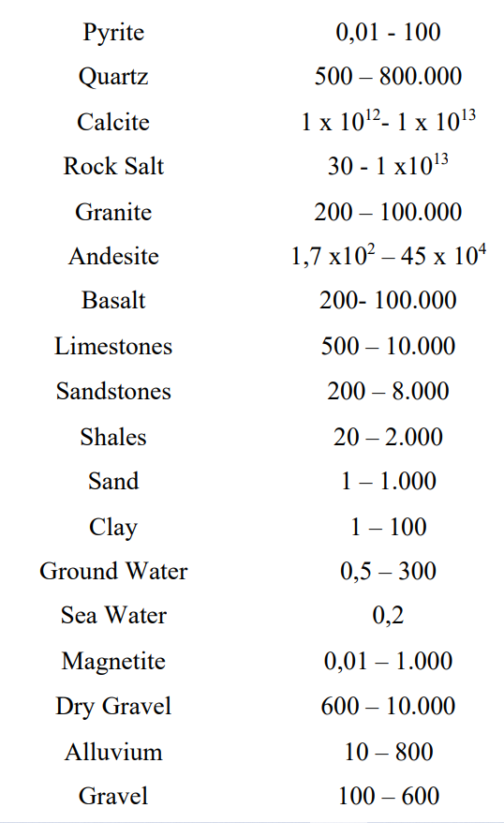Material Resistivity (Ωm)

Electrical resistivity of a layer depends on its material, pore shape and size, density, porosity, water content, temperature etc. Instruments used for conducting vertical electrical sounding survey were a resistivity meter (MODEL-SSR-MP1), two potential electrodes, two current electrodes, wires and wire holders. There are two common arrangements of electrode spacing i.e., Schumberger arrangement and Wenner arrangement. The VES survey has been carried out by Schumberger arrangement with maximum current electrode spacing of 300 m. After the field survey, curve matching of VES data has been done by IPI2win software. Schumberger arrangement of electrode spacing has been shown in the figure 3.

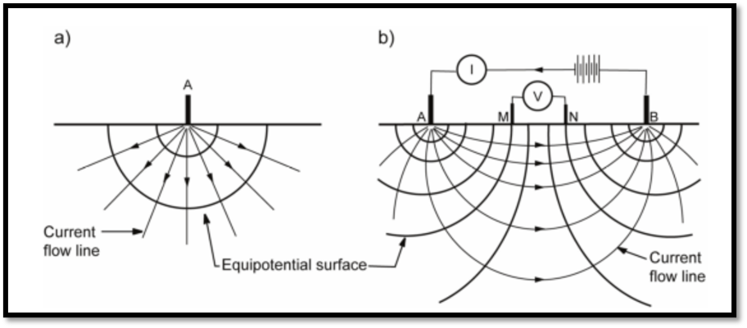

*Figure 3 Direction of current flow lines and equipotential lines in Schumberger arrangement*

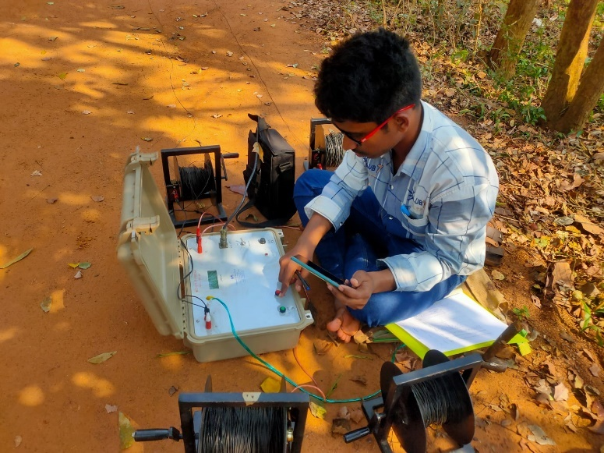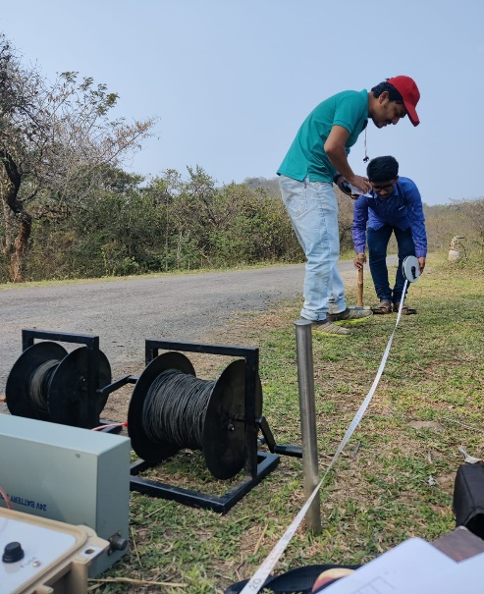

*Figure 4 Vertical Electrical Sounding survey in the field*

Here, Distance between potential electrodes (MN) = b

Distance between current electrodes (AB) = L

Schumberger’s arrangement gives a better result when L≥5b. Apparent resistivity (ohm-m) of a layer has been given by the following formula,

ρa = .............. iii

Where R is the resistance of layer in ohm obtained from resistivity survey.

A subsurface geoelectric layer is described by two fundamental quantities. One is apparent resistivity (ρa ) and another is the thickness of the layer (Austin et al. 2015). Dar- Zarrouk parameters i.e., longitudinal conductance (S) and transverse resistance (T) has been estimated by using the following formulas:

S=h/ ρa, in Ω-1 .............. iv

T=h. ρa, in Ω.m2 .............. v

High value of longitudinal conductance (S) represents a thick layer and claims higher priority in terms of groundwater potential (Austin et al. 2015)

If the transverse resistance has a very high value, it may signify a large value of transmissivity of aquifer. It is an important parameter to define a good groundwater potential zone.

The Protective capacity of an aquifer is defined as its ability to filter and retard the percolating polluted fluid from surface water to subsurface auriferous zone. The protective capacity of an aquifer is directly proportional to the value of longitudinal conductance as shown in the table 9 (Austin et al.2015)

|  |  |  |  |  |  |  |
| --- | --- | --- | --- | --- | --- | --- |
| **Longitudinal Conductance (Ω-1)** | **>10** | **5-10** | **0.7-4.9** | **0.2-0.69** | **0.1-0.19** | **<0.1** |
| Rating of protective capacity | Excellent | Very good | Good | Moderate | Weak | Poor |

Table 9 *Longitudinal conductance vs Rating of protective capacity*

### Validation Using Pearson’s Correlation Coefficient

Statistically, Pearson correlation coefficient or Pearson’s r is a measure of linear correlation between two sets of data. In this case, two sets of data are groundwater level below the surface in the y axis and groundwater potential index value in the x axis. Groundwater level data has been obtained from Central Ground Water Board (CGWB) datasets. The correlation coefficient can be evaluated by the following formula:

$r= \frac{\sum{(x_{i}-\overline{x})(y_{i}-\overline{y})}}{\sqrt{\sum{{(x_{i}-\overline{x})}^{2}\sum{{(y_{i}-\overline{y})}^{2}}}}}$.............. vi

The relation between two variables and the value of correlation coefficient determines the consistency of the model.

## Water Quality Assessment

To check out the groundwater quality of the study area, water samples have been collected from 19 locations. Total Dissolved Solid, Electrical conductivity, pH, Chloride, Total Hardness, Alkalinity, Iron, Sulphate, Phosphate, and Nitrate all of these parameters of water samples have been measured in the water quality laboratory. Considering the acceptable limit of different water quality parameters as per IS 10500:2012, Water Quality Index for every sample was calculated by the Weighted Arithmetic Index method suggested by Brown (1972) and risk zones of water pollution were identified.

Drinking Water Quality standards for these general parameters as per IS 10500: 2012 have shown in table 10.

*Table 10 Drinking water quality standards as per IS 10500:2012*

|  |  |  |
| --- | --- | --- |
| **Water quality** | **Acceptable limit** | **Permissible limit** |
| pH | 6.5-8.5 | No relaxation |
| Total Dissolved Solids(mg/L) | 500 | 2000 |
| Electrical Conductivity*(µS/cm) | 400 | … |
| Chloride (mg/L) | 250 | 1000 |
| Total Hardness (mg/L as CaCO3) | 200 | 600 |
| Total Alkalinity (mg/L as CaCO3) | 200 | 600 |
| Iron (mg/L) | 1 | No relaxation |
| Sulphate (mg/L) | 200 | 400 |
| Phosphate (mg/L) | 1 | … |
| Nitrate (mg/L) | 45 | No relaxation |

### Water Quality Descriptions & Test Procedures

#### pH, TDS and Electrical Conductivity

pH value denotes whether the water is acidic or alkaline. pH value greater than 7 indicates alkaline water and pH value less than 7 indicates acidic solution.

Total dissolved solids (TDS) mean the portion of total solids that passes through filter media after the removal of suspended solids. Generally, particles having size less than 0.5 to 2 micron characterized as dissolved solid.

Electrical conductivity of water is a measure to check how easily electric current passes through it. Its value directly depends on the number of ions or electrolytes present in the water. Generally, saline water has higher value of electrical conductivity than that of drinking water.

TDS, pH, EC all of these three parameters has been measured at the field level using ‘combined pH and EC probe made by HANNA’

Measured values of TDS, pH and EC have been shown in table 25.

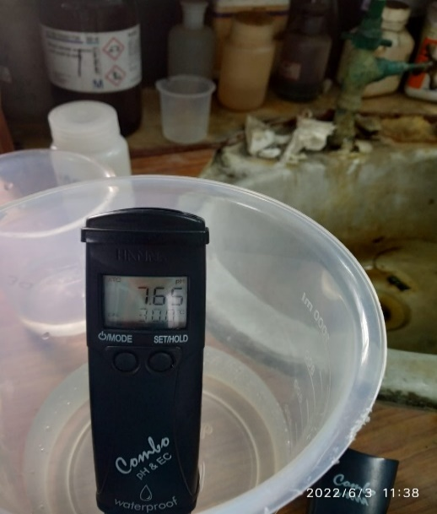

Figure 5 *Probe to measure pH, TDS & EC*

#### Chloride

Chlorides in drinking water may be present in combination with one or more cations like Ca2+, Mn2+, Na+, Fe2+Chlorides ion in water samples have been determined in pH range 7 to 10 (slightly alkaline solution) by titration with standard silver nitrate (AgNO3) solution (0.0141 N) using potassium chromate (K2CrO4) as indicator. The Chloride concentration has been determined using equation vii and chloride concentration in each water sample has been shown in table 25

Chloride (mg/L) = $\frac{(A-B)×N×35400}{ml of sample }$.............. vii

Where A = AgNO3 required for titration (ml)

B = AgNO3 required for blank (ml)

N= Normality of AgNO3

#### Total Hardness

A water sample is said to be hard if excessive soap is required to produce lather. Hardness of water is caused by divalent cations in water. Hardness causing cations are Ca2+, Mg2+, Fe2+, Mn2+ and major anions associated with these cations are SO42-, CO32-, HCO3-, Cl- etc. Generally, total hardness of water is defined as the sum of Ca2+ and Mg2+ concentrations and expressed as mg/L as CaCO3.Carbonate and bicarbonates causes temporary hardness. Chloride and Sulphate anions causes permanent hardness.

To measure the total hardness, Eri chrome black T indicator has been added in the water sample in slightly alkaline condition (pH 10±0.1) and the solution has been titrated using standard EDTA titrant (0.01 N).

Total hardness, as mg/L as CaCO3 = .............. viii

Where A= EDTA used in titration process (ml)

#### Total Alkalinity

Alkalinity of water is the acid neutralizing capacity and expressed as mg/L in terms of CaCO3. There are mainly three types of alkalinities viz. hydroxide alkalinity, carbonate alkalinity and bicarbonate alkalinity. To find the total alkalinity in the laboratory, 2-3 drops of mixed bromocresol green- methyl red indicator has been added to 50 ml of water sample and titrated with 0.02 N H2SO4, until the colour changes from green to red.

Alkalinity in mg/L as CaCO3 = .............. ix

A = standard diluted sulphuric acid used (ml)

N = Normality of acid (here, 0.02 N)

Measured values of total alkalinity of different samples have been shown in table 25.

#### Iron

Iron can cause bad taste to water, causes discolouration to clothes and causes coating to the pipes. To prevent the oxidation of ferrous ion, 2 ml of conc. hydrochloric acid was added in 100 ml of sample water and collected in a separate container. The samples have been preserved in ice-box to avoid direct sunlight.

In the laboratory, ‘FerroVer Iron Reagent Powder Pillow, Hach India’ has been added to 10 ml sample in a glass container. Then the concentration of iron has been determined by spectrophotometer (model- Spectroquant Pharo 300). It measures the colour intensity at 510 nm wavelength. The test results have been listed in table 25.

#### Sulphate, Phosphate and Nitrates

These three tests have been carried out in laboratory using a spectrophotometer (model- DR 2800, by HACH). Three different pillow powders have been used to measure these anions in water samples.

*Table 11 Pillow powders used for Sulphate, Phosphate and Nitrate test*

|  |  |
| --- | --- |
| **Water parameters** | **Name of pillow powders** |
| Sulphate | SulfaVer® 4 Sulfate Reagent Powder Pillows,  HACH India |
| Phosphate | PhosVer 3 Phosphate Reagent powder Pillows,  HACH UK |
| Nitrate | NitraVer® 5 Nitrate Reagent Powder Pillows,  HACH USA |

These chemicals have been added to 10 ml of water sample and concentration has been measured using the above-mentioned spectrophotometer. Sulphate and been measured at 420 nm wavelength. Nitrate has been identified at 220 nm and 275 nm wavelengths.

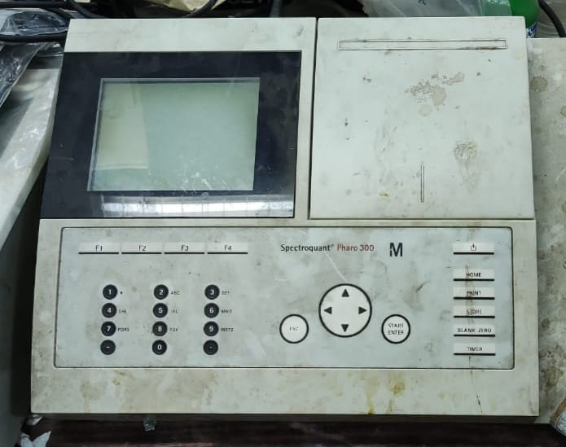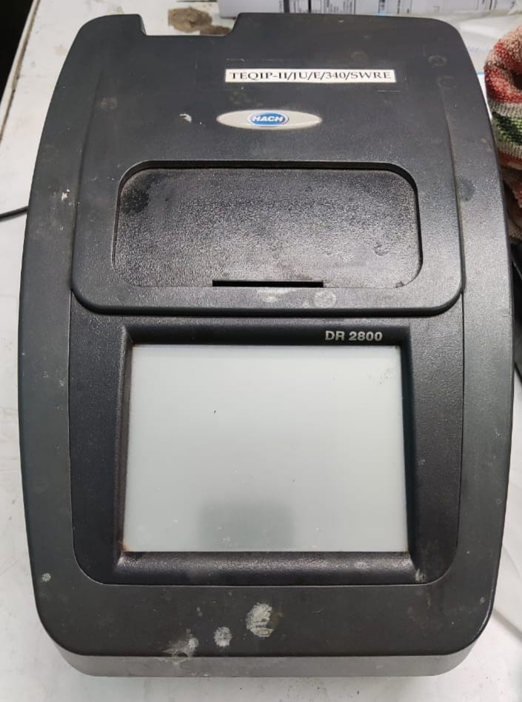

.

*Figure 6 Spectrophotometer DR 2800 (SO42-, PO43- &NO3* -) *Figure 7 Spectroquant Pharo 300*

### Water Quality Index

General water quality parameters and their measured values mentioned in table 25 have been used to calculate water quality index. This study will help us to estimate the groundwater pollution scenario of the basin. Groundwater quality index is a number by which water quality data is reported to the public in a easy and summarized way. The water quality indexes of the study locations have been estimated by ‘Weighted Arithmetic Index Method’ or Brown’s method. The step-by-step methodology to find WQI has been shown below:

* Calculate the unit weight factors (Wn) for each parameter by using the formula:

Wn = .............. x

Where k = $\frac{1}{\sum{S_{n}}}$.............. xi

Sn = Standard desirable value for nth parameter as mentioned in table

* Sub-index value has been calculated by the following formula:

Qn =( )×100 ................. i

Vn = Mean concentration of nth parameter

Sn = Standard desirable value of nth parameter

V0 = Actual value of the parameters in pure water (V0=0 for most of the parameters. For pH, V0=0)

Value of overall WQI= $\frac{\sum{W_{n}}Q_{n}}{\sum{W_{n}}}$.............. xii

The quality status of water depends on the value of water quality index as shown in table 12. If WQI is more, the water is more polluted.

*Table 12 WQI value vs water quality status*

|  |  |  |  |  |  |
| --- | --- | --- | --- | --- | --- |
| **WQI value** | **0-25** | **26-50** | **51-75** | **76-100** | **>100** |
| Water quality status | Excellent | Good | Poor | Very poor | Unsuitable for drinking |

Conventional maps and remote sensing data

Field survey generated data

Qualitative and quantitative assessment of groundwater of the study area

Validation of the model with VES survey data

Porosity, permeability, water holding capacity

Water quality parameters

Generation of thematic layer maps in ArcGIS

Categorization & weight assignment by MCDM method

Curve matching and identification of geoelectrical layers of the study area

Execution of VES survey in the study area

Validation of the model using Pearson correlation coefficient

Generation of final groundwater potential map

Calculation of water quality index

Integration of all the thematic layers in ArcGIS

*Figure 8 Methodology of the thesis work*

# Chapter: Concepts & Criteria

## Descriptions of different thematic layers

### Drainage Density

Drainage density can be defined as the closeness of the steams or different channels per unit area of a basin (Halder et al 2021). Drainage density is inversely proportional to the groundwater recharge. From the groundwater recharge prospects, a higher rank has been assigned for an area having low drainage density. Drainage density for the study area has been calculated using the Hortons method (Horton 1945) expressed as:

Dd =L/A .............. xiii

Where L= total length of the stream in km and A= Area in km2.

In the Silabati-Joypanda river basin, drainage density (figure 9) can be classified into five classes namely very high (56.82%), high (35.25%), moderate (6.70%), low (0.48%), and very low (0.06%). As the study area belongs to the upper basin of the Silabati river, many hard rock formations can be found in the study area. So, less permeable rocks cause higher drainage density and less groundwater recharge.

### Geology

The geological formation is one of the essential parameters for groundwater recharge. It controls the movement and percolation of water to the deep subsurface layer. The study area has different types of geological formations (figure 10) like Laterite (0.43%); Sand, silt and clay (40.79%); Granite gneiss (1.4%), Ferruginous sediments with rock fragments (0.49%); Mica schist, occasionally granitiferrous (10.1%), Pink granite/biotite-granite gneiss (40.67%), Metamorphosed basic Rocks (0.29%), Granite Gneiss, migmatite (4.57%); Sand, Silt, Gravel (0.06%); Quartz, phyllite, granite, pebbles and gravels (1.16%). Sand, silt and clay are predominant in the southern part of the study area which has good recharge and percolation capacity. But, in the northern region, pink granite/biotite-granite gneiss causes less recharge and signifies poor groundwater potential. The calculated weights of different sub-parameters are mentioned in the table 7.

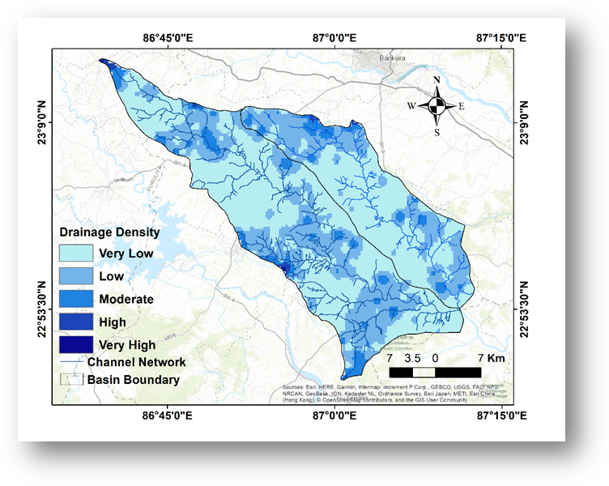

Figure 9 *Drainage Density map of the study area*

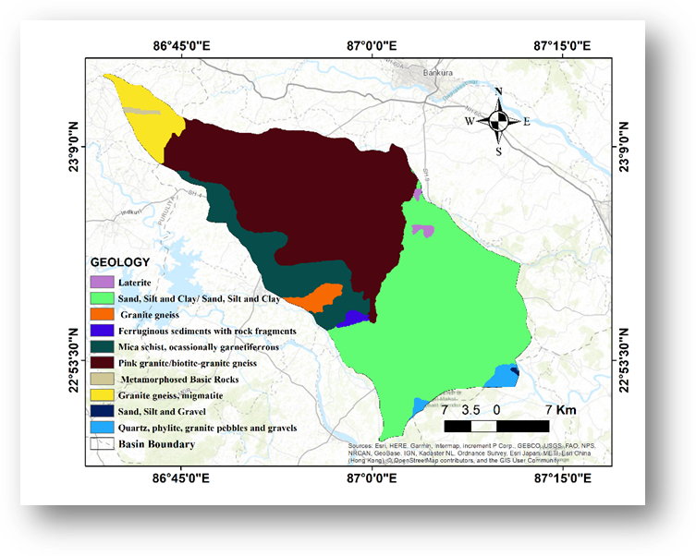

*Figure 10 Geology map of the study area*

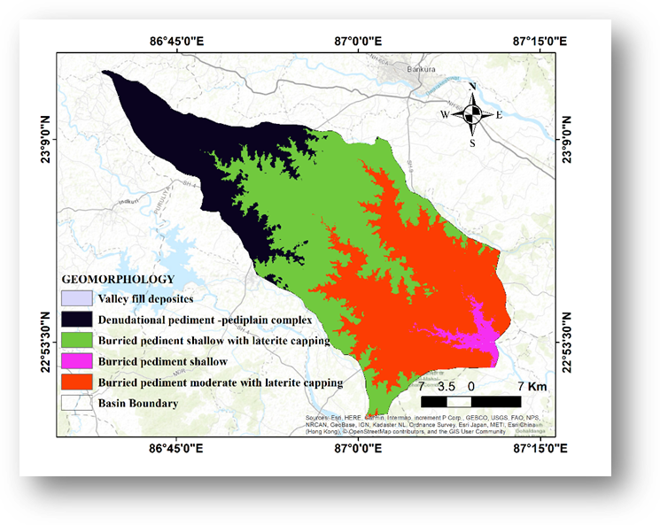

*Figure 11 Geomorphology map of the study area*

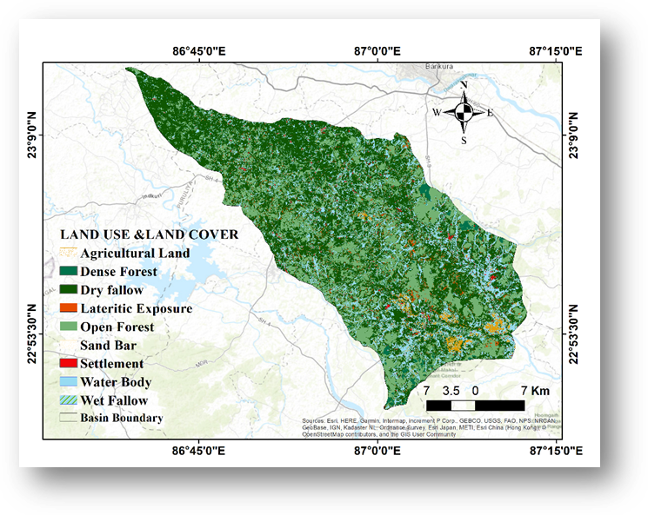

*Figure 12 Land use and land cover map of the study area*

### Geomorphology

Geomorphology of a study area is characterized by lithology, landform and rock structure of a study area and has a significant contribution to groundwater prospects (Roy et al. 2020). The geomorphic configuration of the study area (figure 11) is consisting of a Denudational pediment-Pedi plain complex (21.85%), Buried pediment shallow with Laterite capping (39.26%), Buried pediment moderate  
 with Laterite capping (36.24%), Buried pediment shallow (2.45%), and Valley fill deposits (0.005%). Almost 97.35% of the total area is under poor groundwater possibility as per geomorphic characteristics.

### Land Use and Land Cover

Land use and land cover play an important role in controlling groundwater and surface water resources. Land use and land cover have a strong impact on hydrological processes like infiltration, surface runoff, and evapotranspiration. Different types of land use and land cover have been observed in the study area (figure 12) are Sand Bar (0.01%), Water Body (4.95%), Lateritic Exposure (1.74%), Settlement (1.17%), Wet Fallow (10.3%), Dry Fallow (47.02%), Dense Forest (3.67%), Agricultural land (1.38%), open forest (29.71%). Dry fallow land gives more surface runoff and less infiltration through the soil and indicates less groundwater prospect. But open forests may have a good groundwater potential. Continuous deforestation and an increase in fallow land are going to be a big problem for groundwater resources in the study area.

### Distance from Lineaments

Lineaments mainly reflect the subsurface geology of a study area where some linear fracture zones are expected to exist. These zones generally have good porosity and permeability. Lineaments influence the movement and storage of groundwater. The area close to a lineament has good groundwater prospects. About 52.28% area of the basin is within 1000m distance from lineament and 30.16% area is within 2000m distance from lineament which has a possibility of good groundwater potential (figure 13).

### Porosity of Soil

The porosity of the soil mass is defined as the ratio of the volume of voids to the total volume of soil. It is denoted by the letter symbol n and commonly expressed as a percentage.

$n=\frac{V_{v}}{V}×100 \%$.............. xiv

Where Vv is the volume of void and V is the total volume of the soil.

Good porosity of soil enhances infiltration of water through the soil pores. So, it results in good groundwater recharge and may have good groundwater potential. The porosity of soil for different sites in the study area was directly determined in the laboratory. The porosity test has been carried out by saturating the soil sample in a measuring cylinder and the volume of the void was determined by the amount of water absorbed by the saturated soil sample. Finally, equation xiv was used to determine the porosity of that soil sample.

*Table 13 Porosity of the soil samples*

|  |  |  |  |
| --- | --- | --- | --- |
| **Porosity** | | | |
| ***Village Name*** | ***The volume of Soil (ml)*** | ***The volume of Absorbed Water (ml)*** | ***Porosity, n (%)*** |
| Aralbara | 42 | 23 | 54.76 |
| Bansidi | 33 | 19 | 57.58 |
| Baragram | 33 | 13 | 39.39 |
| Baromesya | 52 | 24 | 46.15 |
| Bara Metala | 37 | 18 | 48.65 |
| Dumuria | 43 | 22 | 51.16 |
| Gharpathar | 43 | 23 | 53.49 |
| Guniada | 30 | 23 | 76.67 |
| Kantapal | 40 | 19 | 47.50 |
| Kawabasa | 39 | 10 | 25.64 |
| Kolaboti (Susunia) | 38 | 16 | 42.11 |
| Kusumdunri | 43 | 21 | 48.84 |
| Kharjuria | 60 | 24 | 40.00 |
| Metyal | 40 | 19 | 47.50 |
| Niasa | 45 | 22 | 48.89 |
| Pachaparar | 33 | 10 | 30.30 |
| Poradi | 42 | 20 | 47.62 |
| Rampur | 48 | 22 | 45.83 |
| Upar Maity Bandh | 57 | 30 | 52.63 |

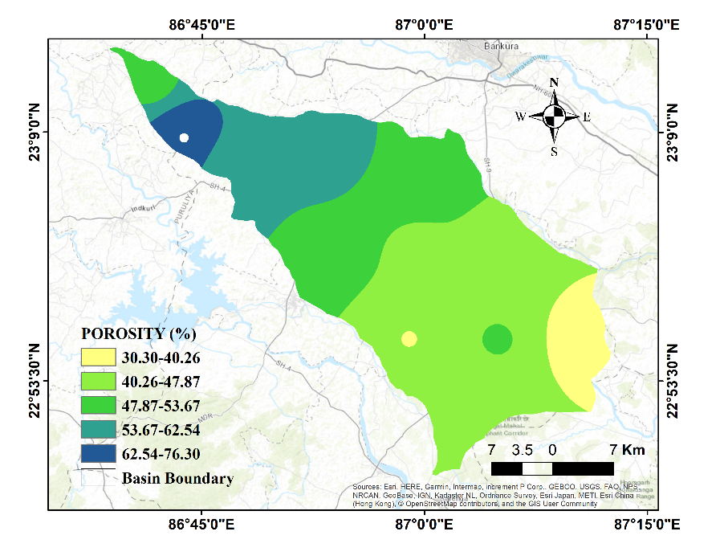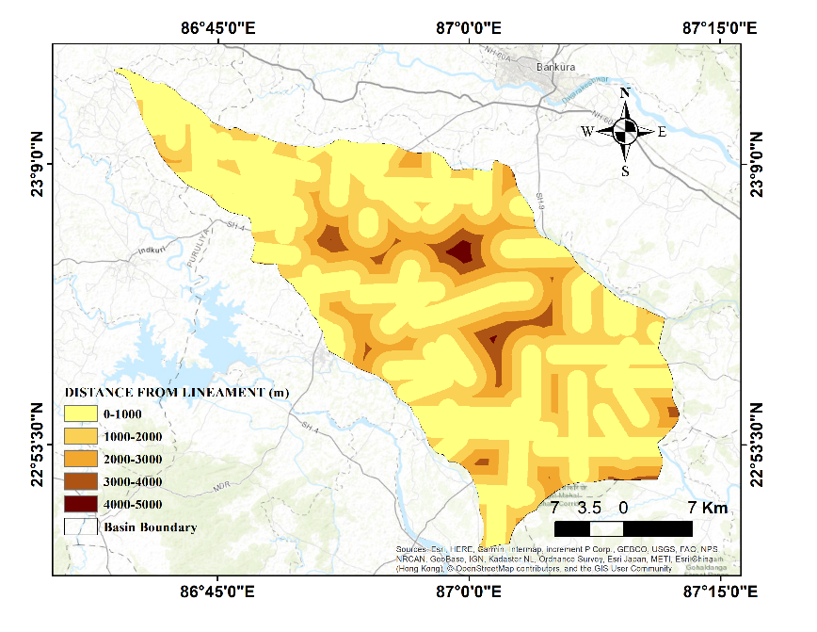

*Figure 13 Distance from lineament map of the study area*

*Figure 14 Porosity map of the study area*

### Runoff

The runoff of a basin has an inverse relationship with groundwater potential. More runoff indicates less infiltration of rainwater and groundwater recharge becomes insignificant. The runoff of the Silabati and Joypanda river basin was calculated using Soil Conservation Service (SCS) curve number (CN) method. SCS curve number method estimates precipitation excess as a function of cumulative precipitation, soil type, land use and antecedent moisture content (AMC). The runoff curve number depends on two issues- (i)Type of land use and (ii)Hydrologic soil group. SCS curve number method is applicable for small basins having an area less than 400 sq miles or 1036 sq km. So, we can apply this method to the Silabati basin (723.43 km2) as well as the Joypanda river basin (375.89 km2). Step by step process to calculate the runoff is shown in figure 16. The annual final runoff depth for the Silabati and Joypanda river basins is estimated as 1758.70 mm and 1718.21 mm respectively.

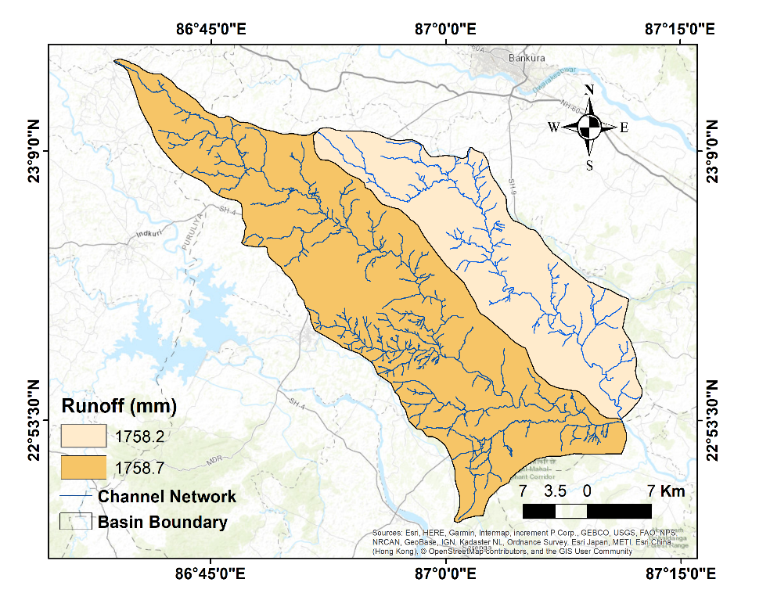

*Figure 15 Runoff map of the basin*

USGS Landsat 8 OLI

o

Soil data (NBSS&LUP)

CHIRPS rainfall data

Land Use Map

Hydrologic Soil Group map

Estimation of Antecedent Moisture content (AMC)

Selection of CN for normal condition or AMC II

**Determination of CN for dry condition (AMC I) and wet condition**

**(AMC III) using the following formulas:**

$$CN I=\frac{4.2×CN II}{10-0.058×CN II}$$

$$CN III=\frac{23×CN II}{10+0.13 CN II}$$

Calculation of Area Weighted CN for AMC I, II, III

Determination of Surface Retention using the formula:

$$S=\frac{25400}{CN}-254$$

**Estimation of Excess Rainfall or Direct Runoff depth using the formula: $=\frac{{(P-0.3×S)}^{2}}{(p+0.7×S)}$, P>0.3×S Where, P is the Total Precipitation**

*Figure 16 Process flow of runoff calculation by SCS curve number method*

*Table 14 Runoff calculation of Joypanda Basin*



*Table 15 Runoff calculation for Silabati river basin*



### Rainfall

Rainfall is a very important hydrological source of groundwater and it also determines the fluctuations of subsurface water level from season to season (Das et al. 2018). The distribution of rainfall along with slope gradient has a major effect on the infiltration of runoff water and increases the possibility of good groundwater prospects. Almost 72% of the total annual rainfall occurs in the monsoon season because of the southwest monsoon wind during the month from June to September. The monthly average rainfall of the study area ranges from 141 mm to 155 mm. In the southern and western parts of the study area rainfall intensity is more. But, in the northern part, the intensity of rainfall is relatively less (figure 17).

### Soil Class

Soil texture influences percolation rate and therefore groundwater potential of a study area. The soil map has been downloaded from the National Bureau of Soil Survey and Land Use Planning (NBSSLUP). The soil texture of the basin was classified into six different categories (figure 18). These are: fine (24.17%), fine loamy to coarse loamy (6.6%), fine loamy (43.05%), gravelly loam (1.83%), fine loamy to sandy (16.69%) and gravelly loam-loam (7.6%). Sandy and gravelly soil have good percolation capacity and hence good groundwater possibilities. Clayey soil has poor percolation capacity and poor groundwater potential.

### Distance from Wells

The existence of high-yield dug wells in a location is a good indication of excellent groundwater potential. So, areas close to the wells have good groundwater possibilities. The well locations were identified from hydrogeological maps of the Public Health Engineering Department, Government of West Bengal and were digitized by ArcGIS software of 10.4 version. The wells with 50-100 LPM capacity have been digitized and the ‛Multiple Ring Buffer’ function of the Analysis Tool has been used to get the buffer map of the study area. Then based on distance from wells, the study area was classified into five different classes i.e., 1000-2000 m (52.47%), 2000-4000 m (33.83%), 4000-6000 m (10.0%), 6000-8000 m (2.52%) and 8000-11000 m (1.18%) (figure 19)

### Relative relief

Higher relative relief of the study area encourages surface runoff and may cause poor groundwater potential. Relative relief of the study area has been calculated using Melton’s formula introduced in the year 1957 (Halder et al. 2020). The formula is:

Relative relief, R=∆H/P

Where ∆H is the difference in elevations of the highest and the lowest points of an area and P is the perimeter of the basin. Relative relief of the study area varies from 3.9 m to 83.21 m. Relative relief in this area has been divided into five classes i.e., 3.9-16.5m (17.57%), 16.5-20.9m (43.91%), 20.9-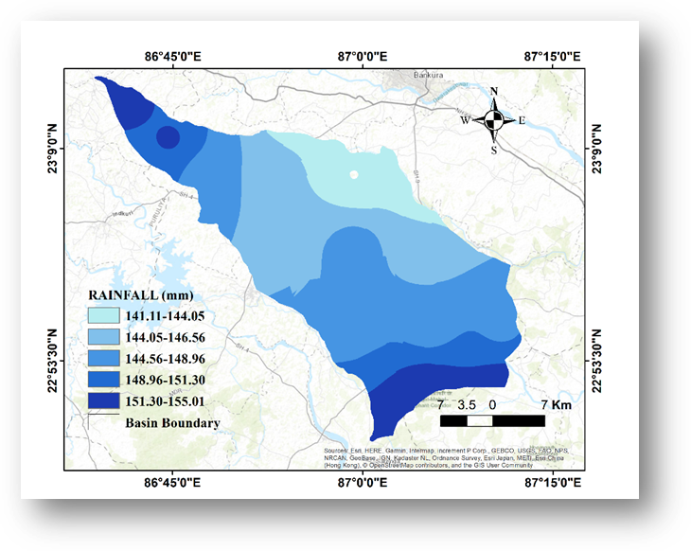26.2m

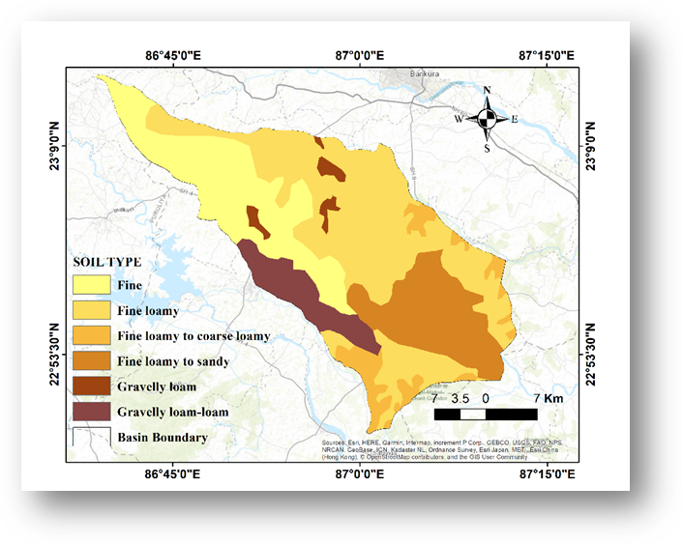

*Figure 17 Rainfall map of the study area*

*Figure 18 Soil map of the study area*

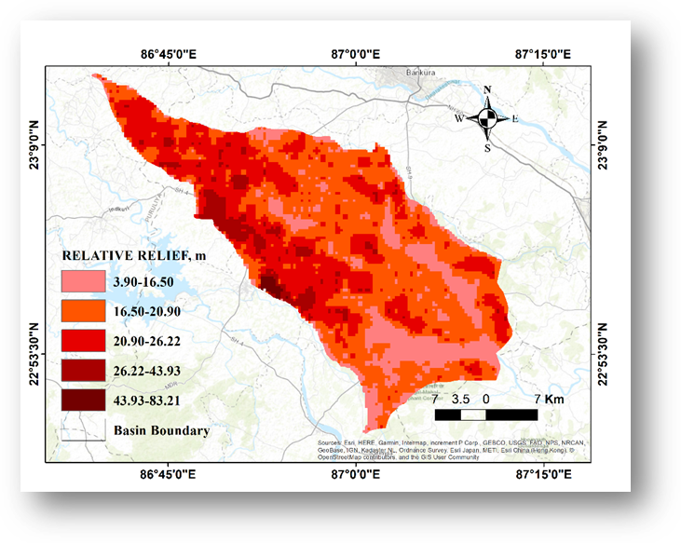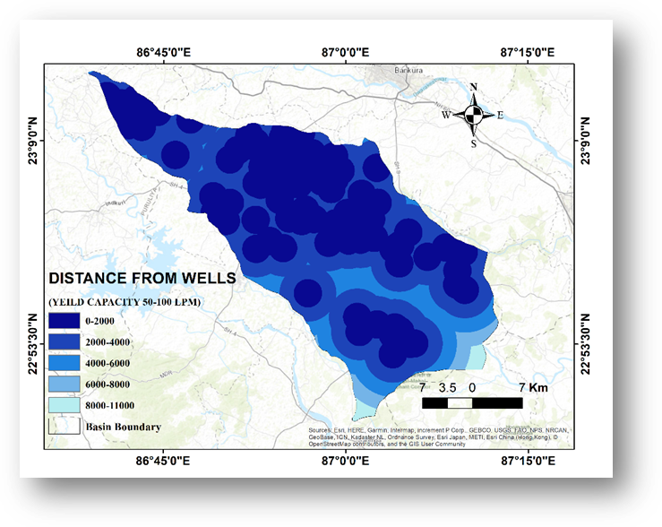

*Figure 19 Distance from the wells map of the study area*

*Figure 20 Relative relief map of the study area*

31.45%), 26.2-43.9m (5.86%), 43.9-83.2m (0.49%). Relative relief is much higher in the upper portion of the river basin as expected (figure 20)

### Permeability or Hydraulic Conductivity

#### Empirical equations

Permeability or Hydraulic Conductivity is a property of soil which allows water to flow from a point of higher energy to a point of lower energy. Permeability plays an important role in rainwater and surface-water infiltration and hence the groundwater recharge. So, higher permeability of soil indicates good groundwater possibility and has been assigned a higher weight. Permeability of soil is directly connected to the discharge velocity of porewater in saturated soil under steady laminar flow conditions. Darcy’s law for the relation between discharge velocity and permeability can be expressed as:

V= k. i .............. xv

Where V is the discharge velocity, k is the permeability and i is the hydraulic gradient (∆h/L).

∆h is the difference in total head

L is the length of the soil mass in between the points for which the head difference is being calculated.

There are some empirical equations by which the permeability of a soil mass can be calculated from sieve analysis data. These are Hazen’s formula, Slichter’s formula, Terzaghi’s formula, Beyer’s formula, Sauerbrei’s formula, Kruger formula, Kozeny’s formula, Zunker’s formula, Zarmarin’s formula, USBR formula. All of the formulas can be expressed as a single mathematical algorithm as per the following:

K = ἀ · φ(n) · de2 · .............. xvi

Where K is permeability or hydraulic conductivity of soil, ἀ is the structure coefficient, φ(n) is a porosity function, de is the effective particle size, $γ$ is the specific weight of the fluid (Water in this case) and $µ$ is the dynamic viscosity of water.

There are some restrictions on applying equations given in table number 11 that they can be applied only to fine, medium, or large-grained sands. But these classifications were not properly stated in the original developments (David A. Chin, Water Resources Engineering, 3rd edition). Later, various researchers carried out comparative studies on these formulas and established those restrictions. Those empirical equations have been shown in table 16.

In the general equation of hydraulic conductivity (Equation xvi), structure coefficient (ἀ) has been assigned a constant value in most of the cases. But it depends on the uniformity coefficient in the case of Bayer’s formula and on D20 in the case of the USBR formula. Porosity function φ(n) depends on the porosity value of the soil which was taken from table 13. Effective grain sizes are D10 in most of the cases. In the case of Sauerbrei’s formula, it is D17 and for the USBR formula it is D20. In the case of Kruger, Kozeny, Zunker and Zamarin formula, the parameters required to calculate the effective grain size have been obtained from the table of sieve analysis data. Ultimately, the value of permeability or hydraulic conductivity has been calculated putting these parameters in equation xvi.

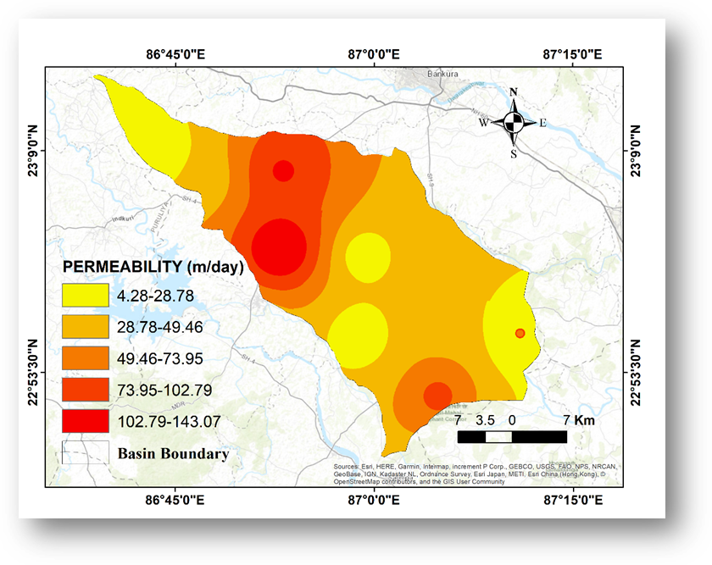

*Figure 21 Permeability or hydraulic conductivity map of the study area*

*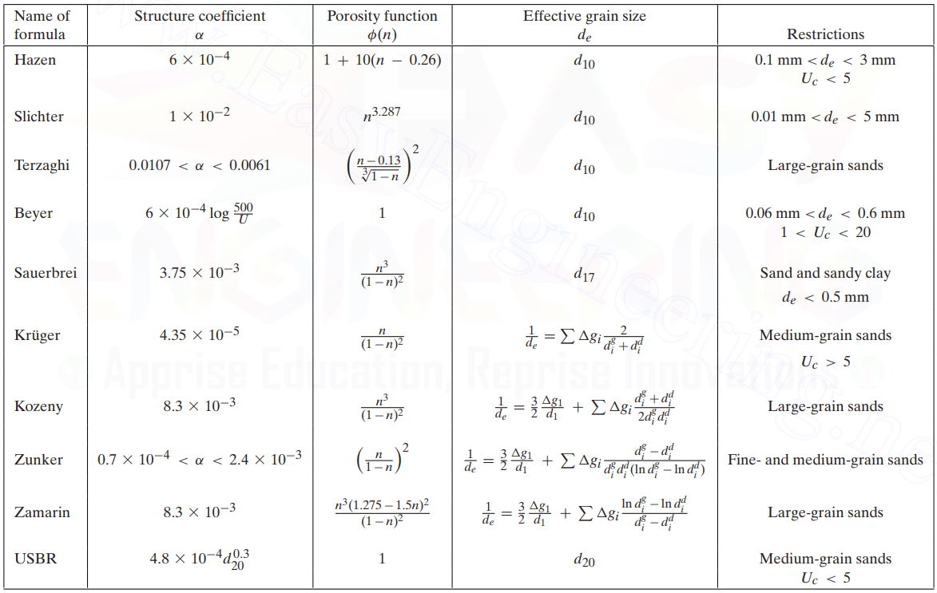Table 16 Empirical formulas for permeability calculation*

#### Sieve Analysis Test for Permeability Calculations

Different grading properties are required to evaluate permeability or hydraulic conductivity by those empirical equations. So, a sieve analysis test has been performed in the laboratory using a mechanical sieve. The step-by-step procedures have been listed below

* The soil samples have been kept in a hot air oven at a temperature of 103 ͦC for three hours to dry the sample completely.
* The weight of each empty sieve (W1) has been measured first.
* Then the samples have been shaken in a set of mechanical sieves of descending sizes. The sieves with diameters of 11.2 mm, 5.6 mm, 4.75 mm, 3.35 mm, 2.36 mm, 1.18 mm, 600 µ, 300 µ, 150 µ, 75 µ, and 38 µ have been used to perform the sieve analysis test. 1 kg of a dried soil sample has been taken for sieving and the total set-up was shaken for 10 minutes in the mechanical sieve.
* Mass of each sieve + Mass of retained soil in each sieve (W2) has been measured by weight machine.
* Subtracting W1 from W2 gives the mass of soil retained (Wn) in each sieve.
* Percentage mass retained in each sieve (Rn) has been calculated using the following formula.

$R_{n}=\frac{W_{n}}{\sum{W_{n}}}×100\%$.............. xvii

Cumulative percentage of soil mass retained (∑Rn) has been calculated.

* Cumulative percentage passing or percentage finer (P) has been calculated by the following algorithm:

P =100 - ∑Rn .............. xviii

* Then, various grading characteristics like D10, D17, D20, D30, D50, D60, D75, and D90 have been determined from the grading curves or interpolating the known data.
* Now, we have to check whether the soil sample fulfils the criteria to apply those empirical equations. For this reason, we need to determine the uniformity coefficient (Uc) and classify the soils based on particle size distribution. Grain size for different soil classes has been mentioned in IS: 1498-1970 as per the following chart:

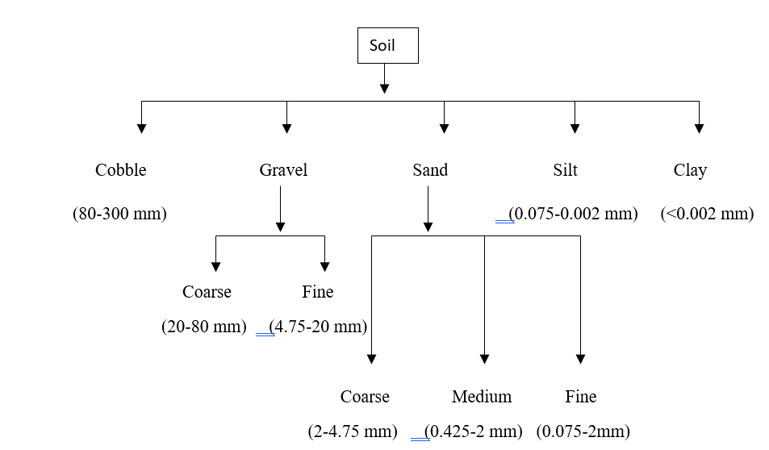

*Figure 22 Soil classification according to grain size*

Uniformity coefficient of a soil sample can be expressed by the formula: $U_{c}=\frac{D_{60}}{D_{10}}$.............. xix

Co-efficient of curvature of soil is given as: $C_{c}=\frac{{D_{30}}^{2}}{D_{60}×D_{10}}$.............. xx

Where D60 = Size at 60% finer by weight

D10 = Size at 10% finer by weight, in most cases, D10 is called the effective size.

D30 = Size at 30% finer by weight

If the uniformity coefficient of the soil is more, then the soil is called well graded. Otherwise, the soil is known as poorly graded. Well-graded soil means more variation in particle size. Coarse-grained soils are divided into well-graded and poorly-graded depending on the Uc and Cc:

Well-graded gravel, Uc >4

Well-graded sand, Uc >6

For both of the cases, 1<Cc<3

|  |  |  |  |  |  |  |  |  |  |  |  |  |  |  |
| --- | --- | --- | --- | --- | --- | --- | --- | --- | --- | --- | --- | --- | --- | --- |
| **Village Name** | **Soil type** | **%Silt** | **%Sand** | **%Gravel** | **D10** | **D17** | **D20** | **D30** | **D50** | **D60** | **D75** | **D90** | **Uniformity Coefficient** | **Coefficient  of Curvature** |
| Aralbara | SP | 1.71 | 97.43 | 0.86 | 0.11 | 0.13 | 0.15 | 0.21 | 0.34 | 0.42 | 0.53 | 1.18 | 3.89 | 0.95 |
| Bansidi | SW-SM | 3.00 | 71.80 | 25.20 | 0.13 | 0.29 | 0.35 | 0.57 | 1.72 | 2.23 | 4.76 | 6.67 | 16.54 | 1.07 |
| Barogram | SW-SM | 0.40 | 97.60 | 2.00 | 0.17 | 0.28 | 0.31 | 0.38 | 0.52 | 0.59 | 1.31 | 2.19 | 3.37 | 1.41 |
| Bara Metala | SM | 12.67 | 86.67 | 0.67 | 0.06 | 0.08 | 0.09 | 0.10 | 0.13 | 0.14 | 0.31 | 1.21 | 2.17 | 1.07 |
| Dumuria | SW | 3.50 | 91.50 | 5.00 | 0.10 | 0.13 | 0.14 | 0.22 | 0.47 | 0.65 | 1.60 | 3.75 | 6.45 | 0.74 |
| Guniada | SP-SM | 6.50 | 61.50 | 32.00 | 0.03 | 0.27 | 0.36 | 1.03 | 2.24 | 3.98 | 5.10 | 8.55 | 119.33 | 7.98 |
| Kantapal | SP-SM | 6.40 | 90.60 | 3.00 | 0.08 | 0.10 | 0.11 | 0.13 | 0.27 | 0.42 | 0.93 | 2.17 | 5.05 | 0.48 |
| Kawabasa | SP-SM | 0.33 | 94.17 | 5.50 | 0.23 | 0.32 | 0.35 | 0.43 | 0.59 | 1.10 | 1.86 | 3.99 | 4.86 | 0.74 |
| Kolaboti (Susunia) | SP | 0.33 | 86.00 | 13.67 | 0.30 | 0.40 | 0.45 | 0.59 | 1.71 | 2.11 | 3.87 | 5.08 | 6.94 | 0.53 |
| Kusumdunri | SP | 0.80 | 94.60 | 4.60 | 0.15 | 0.21 | 0.24 | 0.33 | 0.50 | 0.59 | 1.54 | 3.60 | 4.04 | 1.28 |
| Kharjuria | SP | 3.71 | 75.43 | 20.86 | 0.12 | 0.20 | 0.26 | 0.42 | 1.20 | 1.78 | 4.03 | 11.56 | 14.72 | 0.84 |
| Metyal | SP | 2.75 | 72.00 | 25.25 | 0.10 | 0.13 | 0.14 | 0.26 | 1.01 | 1.88 | 4.77 | 8.13 | 18.37 | 0.35 |
| Niasa | SP-SM | 7.20 | 88.60 | 9.60 | 0.16 | 0.31 | 0.36 | 0.51 | 1.26 | 1.65 | 2.23 | 4.70 | 10.12 | 0.98 |
| Pachaparar | SP-SM | 7.20 | 89.00 | 3.80 | 0.09 | 0.12 | 0.13 | 0.19 | 0.35 | 0.45 | 0.60 | 2.08 | 5.15 | 0.89 |
| Poradi | GW | 1.38 | 34.25 | 64.38 | 0.24 | 0.53 | 0.82 | 2.31 | 9.21 | 12.88 |  |  | 52.98 | 1.70 |
| Rampur | SP-SM | 5.25 | 92.25 | 2.50 | 0.09 | 0.12 | 0.13 | 0.20 | 0.44 | 0.57 | 1.44 | 2.61 | 6.11 | 0.77 |
| Upar Maity Bandh | SW | 1.75 | 66.50 | 31.75 | 0.20 | 0.45 | 0.55 | 1.26 | 2.14 | 3.81 | 5.08 | 7.72 | 18.70 | 2.04 |

*Table 17 Gradation characteristics of soil samples*

*Table 18 Permeability values of soil samples by different empirical equations*

empirical formulas. Now, applying the mentioned restrictions in the table 16, some of the values have been excluded in the final result. The accepted permeability values were shown in green colour and rejected permeability values were shown in red colour. Now, doing an arithmetic average of acceptable permeability values for a particular soil, we get the ultimate permeability value for that soil. Those values have been listed below.

*Table 19 Average permeability values*

|  |  |
| --- | --- |
| ***Site Name*** | ***Permeability (m/day)*** |
| **Aralbara** | 36.83 |
| **Bansidi** | 106.47 |
| **Barogram** | 37.89 |
| **Baromesya** | 40.04 |
| **Bara Metala** | 7.15 |
| **Dumuria** | 21.48 |
| **Guniada** | 6.17 |
| **Kantapal** | 9.12 |
| **Kawabasa** | 25.93 |
| **Kolaboti** | 81.94 |
| **Kusumdunri** | 48.03 |
| **Kharjuria** | 13.62 |
| **Metyal** | 11.94 |
| **Niasa** | 11.94 |
| **Pachaparar** | 3.74 |
| **Poradi** | 60.40 |
| **Rampur** | 16.38 |
| **Upar Maity Bandh** | 143.07 |
|  |  |

These calculated permeability values have been exported to ArcGIS software and the Inverse distance weighted (IDW) interpolation function has been used to get the permeability or hydraulic conductivity raster map of the study area. The study area has been divided into five different classes based on the value of hydraulic conductivity i.e., 4.28-28.78 m/day (20.69%), 28.78-49.46 m/day (44.18%), 49.46-73.95 m/day (16.66%), 73.95-102.8 m/day (14.18%), 102.79-143.07 m/day (4.29%). The central and lower part of the basin area consists of the most permeable soil formations. So, that area has a high chance of good groundwater possibility.

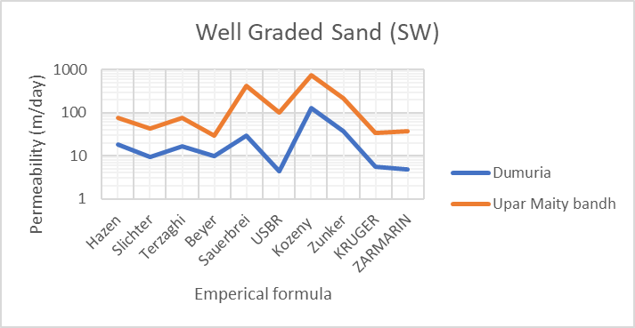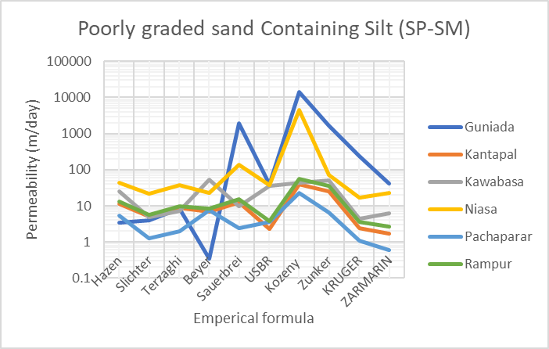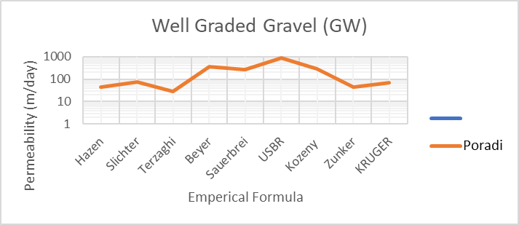

*Figure 23 Graphs of Permeability values by empirical formulas by different soil types*

### Slope

Generally, a flat slope encourages higher infiltration and more groundwater recharge. A steep slope causes higher runoff and inhibits groundwater recharge. The slope map has been prepared using SRTM DEM of 30 m resolution by the Slope function of the spatial analyst tool in ArcGIS software. The slope map of the study area can be divided into five classes i.e., 0.34-1.73 degrees (22.1%), 1.73-3.21 degrees (34.39%), 3.21-5.28 degrees (29.47%), 5.28-9.79 degrees (13.71%), 9.79-36.31 degrees (0.14%). The slope has an inverse relationship with groundwater potential, slope class with a lower value has been assigned a higher weight (figure 24).

### Water Holding Capacity

If the water holding capacity of the topsoil is more, the groundwater recharge will be less. So, Groundwater potential has an inverse relationship with water holding capacity. For example, clayey soil has good water holding capacity and acts as an aquiclude. Hence clayey soil has less groundwater potential. Sand has less water holding capacity. Subsurface sand strata act as a good aquifer and have good groundwater potential.

The water holding capacity of the soil can be defined as the amount of water retained per unit mass of soil. Sometimes, it has been expressed as a percentage. To measure the water holding capacity in the laboratory, a filter paper has been placed in a funnel and a measuring cylinder has been put under that. Some amount of soil (W1) saturated with V1 ml of water has been poured into the funnel. The percolation setup has been left undisturbed for several minutes until no more water trickles through the stem of the funnel. Then the amount of water (V2) collected in the measuring cylinder has been observed. Now, the water holding capacity of the soil sample has been calculated using the following formula:

$WHC= \frac{V_{1}-V_{2}}{W_{1}} ×100\%$.............. xxi

The water holding capacity data found in the laboratory has been exported in the ArcGIS software and a raster map has been prepared with Inverse Distance Weighted (IDW) interpolation. The water holding capacity of the Silabati-Joypanda river basin has been divided into five classes viz; very low (34.44-45.53%), low (45.53-51.66%), moderate (51.66-55.8%), high (55.8-63.42%) and very high (63.42-76.33%). The area extent of each of the classes are 5.67%, 27.48%, 45.31%, 17.86%, and 3.68% respectively. A class with low porosity value has been assigned with low weight and vice versa. The laboratory test result of water holding capacity has been listed below:

*Table 20 Water holding capacity of the soil samples*

|  |  |  |  |
| --- | --- | --- | --- |
| ***Site Name*** | ***Water Holding Capacity*** | | |
|  | ***Weight of  soil (gm)*** | ***Water Retained in soil (ml)*** | ***Water Holding  Capacity (%)*** |
| Aralbara | 16.732 | 8.2 | 49.008 |
| Bansidi | 15.192 | 8.2 | 53.976 |
| Baromesya | 16.17 | 8.4 | 51.948 |
| Bara Metala | 16.88 | 9.6 | 56.872 |
| Dumuria | 15.752 | 9.4 | 59.675 |
| Gharpathar | 17.476 | 7.4 | 42.344 |
| Guniada | 17.348 | 8.6 | 49.573 |
| Kantapal | 15.54 | 8.4 | 54.054 |
| Kawabasa | 14.614 | 9.9 | 67.743 |
| Kolaboti (Susunia) | 16.248 | 7.9 | 48.621 |
| Kusumdunri | 15.392 | 11.8 | 76.663 |
| Kharjuria | 16.838 | 9 | 53.451 |
| Metyal | 15.808 | 5.4 | 34.160 |
| Niasa | 16.854 | 10.1 | 59.926 |
| Pachaparar | 16.34 | 5.6 | 34.272 |
| Poradi | 16.282 | 7.1 | 43.606 |
| Rampur | 15.66 | 8 | 51.086 |
| Upar Maity Bandh | 15.324 | 9.3 | 60.689 |

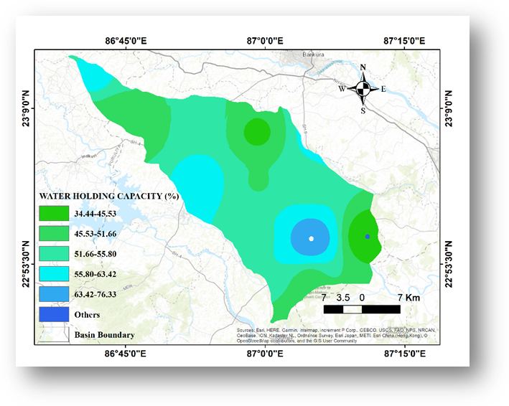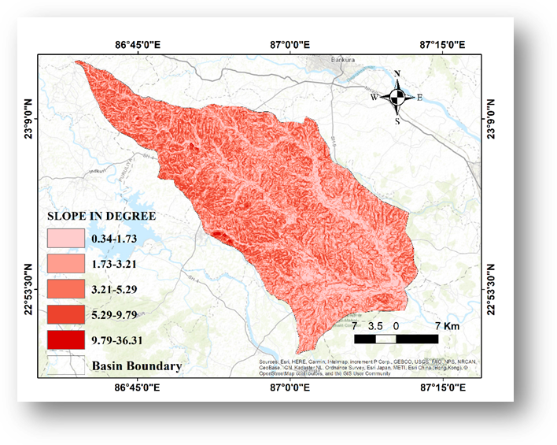

*Figure 24 Slope map of the study area*

*Figure 25 Water holding capacity map of the study area*

## Other Soil Tests

Without porosity, water holding capacity and permeability; some other soil characteristics like specific gravity, moisture content, bulk density and dry density has been measured in laboratory to get a proper scenario of soil characteristic in Silabati-Joypanda river basin. The tests conducted in the laboratory have been described below:

### Specific Gravity Test

Specific gravity is an important soil parameter. Specific gravity of a soil sample has been defined as ratio of its mass in air to the mass of equal volume of water. Mathematically, it can be expressed as:

$G=\frac{ρ_{s}}{ρ_{w}}=\frac{M}{V_{s}×ρ_{w}}$.............. xxii

Where $ρ_{s}$ and $ρ_{w}$ are density of soil particles and density of water respectively. M is the mass of the soil and Vs is the volume of soil.

Determination of specific gravity in the laboratory has been carried out as per IS:2720 (Part-III)-1980. The test has been conducted using 50 cc density bottle. The formula to determine specific gravity is mentioned below:

$G=\frac{(W_{2}-W_{1})}{\left(W_{4}-W_{1}\right)-(W_{3}-W_{2})}$.............. xxiii

Where W1= Weight of the empty density bottle

W2 = Weight of the density bottle + Weight of dry soil (partially filled)

W3 =Weight of the density bottle + Weight of the soil (partially filled) + Weight of water (partially filled)

W4 = Weight of the density bottle + Weight of water (completely filled).

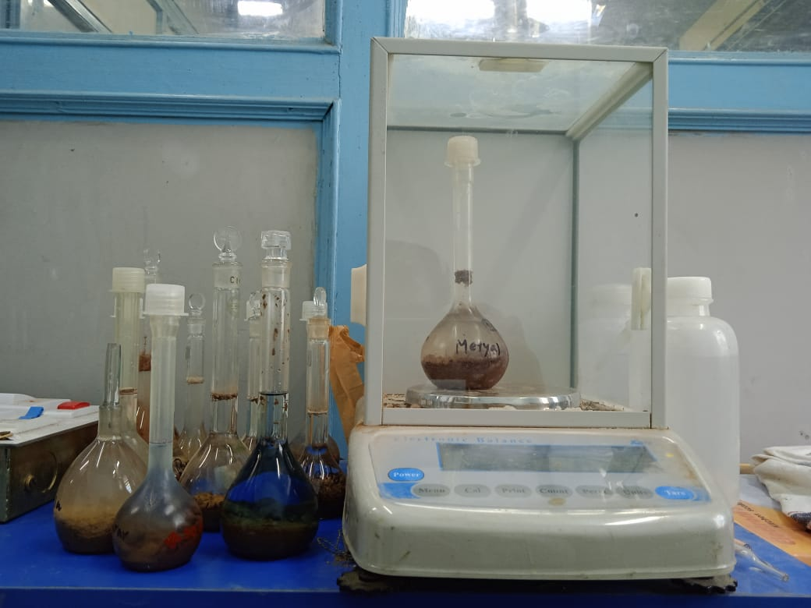

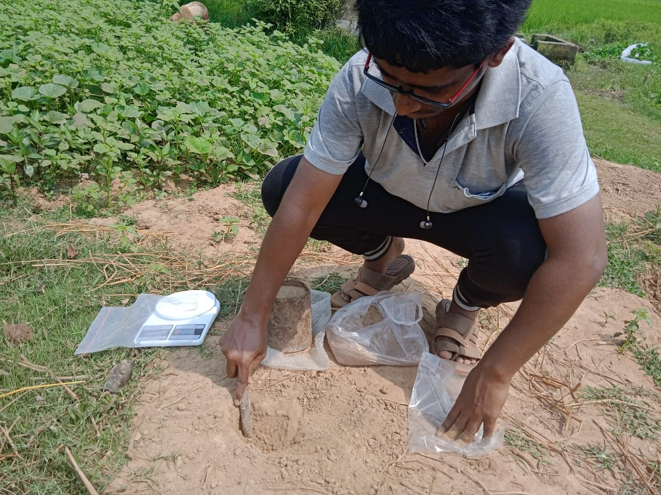

*Figure 26 Specific gravity test arrangement in laboratory*

*Figure 27 Field level bulk density determination using core-cutter*

*Table 21 Specific gravity test results of the soil samples*

|  |  |  |  |  |  |
| --- | --- | --- | --- | --- | --- |
| ***Site Name*** | ***Specific  Gravity*** | | | | |
|  | W1 (g) | W2 (g) | W3 (g) | W4 (g) | G |
| **Aralbara** | 40.23 | 52.18 | 96.72 | 90.11 | 2.24 |
| **Bansidi** | 42.73 | 79.38 | 112.23 | 92.34 | 2.19 |
| **Barogram** | 46.07 | 67.28 | 108.35 | 95.59 | 2.51 |
| **Baromesya** | 13.24 | 37.93 | 76.69 | 63.45 | 2.16 |
| **Bara Metala** | 47.84 | 65.60 | 107.80 | 97.67 | 2.33 |
| **Dumuria** | 13.26 | 35.50 | 75.88 | 63.32 | 2.30 |
| **Gharpathar** | 47.92 | 73.15 | 111.99 | 97.20 | 2.42 |
| **Guniada** | 69.29 | 108.34 | 192.00 | 168.35 | 2.54 |
| **Kantapal** | 39.94 | 55.38 | 94.50 | 85.64 | 2.35 |
| **Kawabasa** | 41.50 | 64.07 | 104.41 | 92.18 | 2.18 |
| **Kolaboti (Susunia)** | 22.15 | 55.49 | 142.39 | 122.06 | 2.56 |
| **Kusumdunri** | 45.89 | 70.23 | 100.92 | 85.03 | 2.25 |
| **Kharjuria** | 13.84 | 37.59 | 77.33 | 63.97 | 2.29 |
| **Metyal** | 20.94 | 78.67 | 155.51 | 121.09 | 2.48 |
| **Niasa** | 41.29 | 73.07 | 157.03 | 139.87 | 2.17 |
| **Pachaparar** | 13.78 | 47.61 | 77.04 | 52.92 | 2.73 |
| **Poradi** | 43.47 | 69.46 | 108.10 | 93.06 | 2.38 |
| **Rampur** | 46.56 | 69.87 | 110.31 | 96.18 | 2.54 |
| Upar Maity Bandh | 47.53 | 66.88 | 107.08 | 97.05 | 2.08 |

From table 21, it has been observed that specific gravity of these sites ranges from 2.16 to 2.73. Different types of soil have different specific gravity values (Venkatramaiah C., Geotechnical Engineering). The grain specific gravities of some common soils have been listed in table 22.

In our study area, in most of the places, soil samples have a major percentage of sand and silt. In a few cases (like Gharpathar), soil sample was plastic clay. But it has been observed that value of specific gravity is little bit less than as mentioned in the table in some cases. As the soil sample has been collected from the upper soil layer, humus content of the soil was quite high. That may be a reason for a little bit low value.

*Table 22 Grain specific gravity for different soil types*

|  |  |
| --- | --- |
| ***Soil type*** | ***Grain specific gravities*** |
| Quartz sand | 2.64-2.65 |
| Silt | 2.68-2.72 |
| Silt with organic matter | 2.40-2.50 |
| Clay | 2.44-2.92 |
| Bentonite | 2.34 |
| Loess | 2.65-2.75 |
| Lime | 2.70 |
| Peat | 1.26-1.80 |
| Humus | 1.37 |

### Moisture Content

Moisture content is a is an important parameter of soil to determine water availability in soil in a particular season or weather condition. The moisture content or water content of soil can be defined as the ratio of the mass of water in the soil pores (Mw) to the mass of solids (Ms).

The water content generally expressed as percentage. Its value can range from zero (dry soil) to several hundred percent (Murthy V.N.S; Soil Mechanics and Foundation Engineering). In the laboratory, moisture content has been determined using oven drying method. At first, some amount of wet soil has been taken and its weight has been measured by weighing machine. Then the soil has been placed in hot air oven at 105℃ for 24 hours. Then the weight of the dry soil (W2) has been measured. Now, the moisture content can be formulated as:

$w=\frac{W_{1}-W_{2}}{W_{2}}×100\%$.............. xxiv

|  |  |  |  |
| --- | --- | --- | --- |
| ***Site Name*** | ***Wet Weight(g)*** | ***Dry Weight (g)*** | ***Moisture  content (%)*** |
| Aralbara | 13.86 | 12.55 | 10.45 |
| Bansidi | 10.66 | 9.29 | 14.78 |
| Barogram | 33.19 | 29.31 | 13.23 |
| Baromesya | 20.99 | 20.53 | 2.22 |
| Bara Metala | 15.91 | 14.74 | 7.92 |
| Dumuria | 34.38 | 33.43 | 2.84 |
| Gharpathar | 26.42 | 23.97 | 10.23 |
| Guniada | 40.35 | 38.89 | 3.75 |
| Kantapal | 10.77 | 10.11 | 6.56 |
| Kawabasa | 38.21 | 36.35 | 5.11 |
| Kolaboti (Susunia) | 90.39 | 86.27 | 4.78 |
| Kusumdunri | 18.27 | 15.49 | 17.92 |
| Kharjuria | 23.26 | 22.63 | 2.77 |
| Metyal | 40.69 | 40.11 | 1.46 |
| Niasa | 13.80 | 12.75 | 8.29 |
| Pachaparar | 25.81 | 25.74 | 0.27 |
| Poradi | 49.53 | 48.16 | 2.85 |
| Rampur | 59.15 | 54.72 | 8.10 |
| Upar Maity Bandh | 29.02 | 25.83 | 12.36 |

*Table 23 moisture content values of the soil samples*

### Bulk Density and Dry Density

Dry density (ρd) of solid particle is a measure of the mass of solid particles per unit volume of the soil sample. Bulk density is a measure of mass of solid particles plus water per unit volume. In-situ bulk density of soil particle is the density of soil mass in undisturbed condition. During the field survey, in-situ bulk unit weight has been measured by core cutter method, sand replacement method and water displacement method. A cylindrical core cutter of 10 cm diameter and 12.7 cm height has been used to measure the bulk density of soil. Dividing the soil mass by the volume of core cutter, bulk density has been obtained. For soil having higher percentage of gravel and hard rock (soil from Poradi and Upar Maity Bandh) sand replacement method was adopted. Water displacement method has been conducted for lump sample of cohesive soil. This type of soil has been obtained from Gharpathar. After getting all the bulk density values, dry densities of soil samples have been obtained from the following formula:

$ρ_{d = \frac{ρ_{t}}{1+W_{c}}}$.............. xxv

Where ρd = Dry density of soil (g/cc)

Ρt = In-situ bulk density of soil (g/cc), Wc = Moisture content of soil obtained from table 23

Table 24 Bulk density & dry density values of the soil samples

|  |  |  |
| --- | --- | --- |
| **Site Names** | **Bulk Density**  **(g/cc)** | **Dry density**  **(g/cc)** |
| Aralbara | 1.42 | 1.28 |
| Bansidi | 1.50 | 1.31 |
| Barogram | 1.54 | 1.36 |
| Baromesya | 1.46 | 1.42 |
| Bara Metala | 1.59 | 1.47 |
| Dumuria | 1.43 | 1.39 |
| Gharpathar | 1.94 | 1.76 |
| Guniada | 1.39 | 1.34 |
| Kantapal | 1.61 | 1.51 |
| Kawabasa | 1.51 | 1.43 |
| Kolaboti (Susunia) | 1.66 | 1.59 |
| Kusumdunri | 1.72 | 1.45 |
| Kharjuria | 1.41 | 1.37 |
| Metyal | 1.64 | 1.62 |
| Niasa | 1.32 | 1.22 |
| Pachaparar | 1.67 | 1.67 |
| Poradi | 1.54 | 1.50 |
| Rampur | 1.81 | 1.68 |
| Upar Maity Bandh | 1.29 | 1.15 |

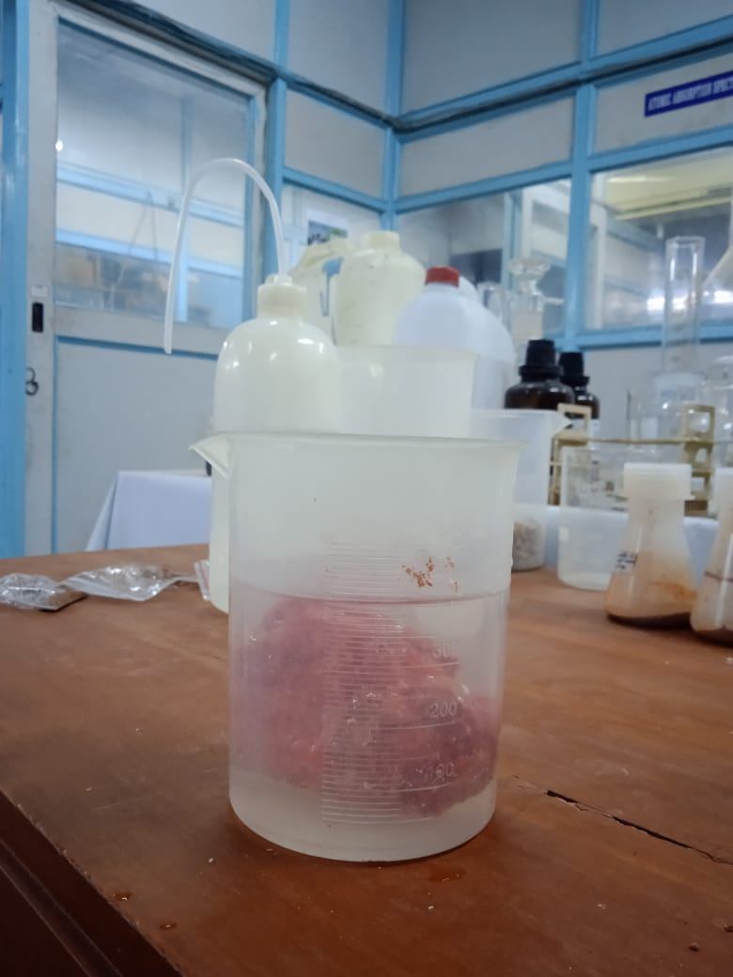

Figure 28 Determination of bulk density by water displacement method

# Chapter: Results and Discussions

## Delineation of Groundwater Potential Zone

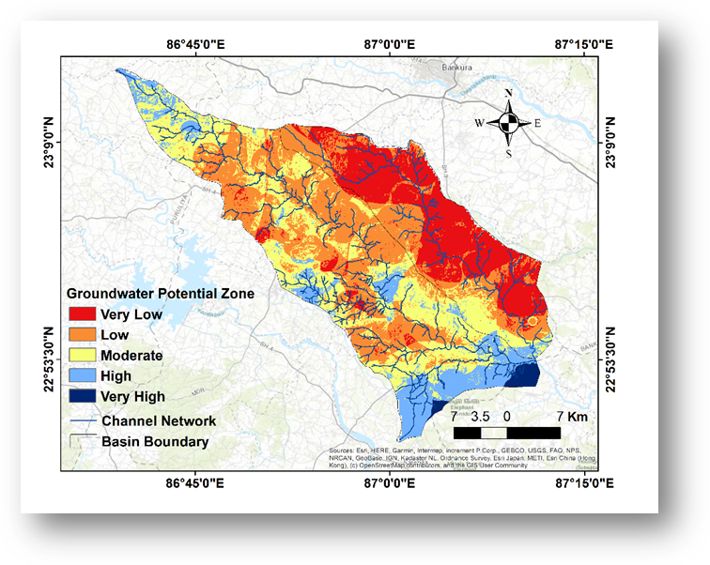The groundwater potential zone of the study area has been delineated using fourteen surface, subsurface parameters and field estimated soil parameters. Weights of different thematic layers has been assigned using analytical hierarchy process. Soil is a very important criteria that influences groundwater possibilities in a region. So, different soil parameters like soil texture, porosity, permeability and water holding capacity have been assigned separately to check the influence of each property of soil. The weights assigned for each criterion are: drainage density (0.014), land use and land cover (0.02), porosity (0.04), rainfall (0.228), relative relief (0.01), slope (0.041), water holding capacity (0.044), geology (0.064), geomorphology (0.096), distance from lineaments (0.052), runoff (0.034), soil texture (0.054), distance from high yield wells (0.159), permeability or hydraulic conductivity (0.096). The groundwater potential zone map has been obtained by integrating all the thematic layers using weighted overlay tool in ArcGIS. The groundwater potential index varies from 1.37 to 4.17. The study area can be classified in five different classes based on groundwater potential index i.e., very low (1.37-2.14), low (2.14-2.44), moderate (2.44-2.72), high (2.72-3.30) and very high (3.30-4.17). The percentage area covered by each class has been shown in the figure 30 for Silabati and Joypanda river basin:

*Figure 29 Groundwater potential zone map of the study area*

From the groundwater potential map, it has been observed that most of the areas of low groundwater potential belong to Joypanda river basin. Impermeable clayey loam soil, less rainfall and excessive undulations of that area may be the reason for low groundwater potential. Very high groundwater potential has been observed in the lower part of the basin. Due to abnormal climate change in the recent years, rainfall distribution became inconsistent in this basin (Halder et al. 2020). That’s why groundwater recharge has reduced and many surface water bodies have dried up. Due to excessive population pressure and agricultural activities, groundwater abstraction is increasing day by day. From the groundwater potential index data, suitable artificial recharge zones can be identified that would increase groundwater availability of the basin.

*Figure 30 Percentage area for each potential class for Silabati and Joypanda basin*

## Water Quality Assessment

General water quality parameters and their measured values (table 25) have been used to calculate water quality index. This study will help us to estimate the groundwater pollution scenario of the basin. Groundwater quality index is a number by which water quality data is reported to the public in an easy and summarized way. The water quality indexes of the study locations have been estimated by ‘Weighted Arithmetic Index Method’ or Brown’s method. General water quality parameters and WQI values have been enlisted in table 25.

*Table 25 General water quality parameters and water quality index values*

**

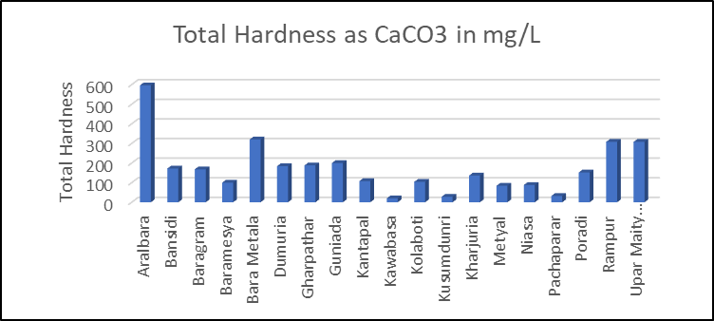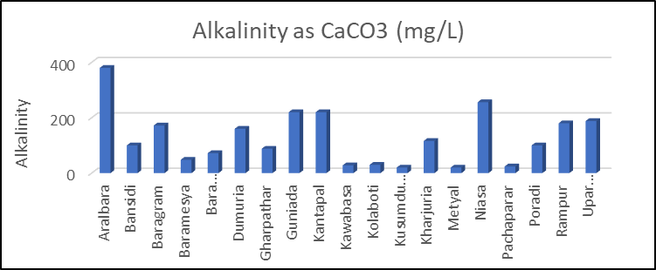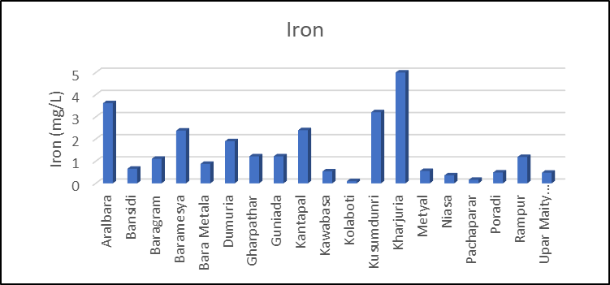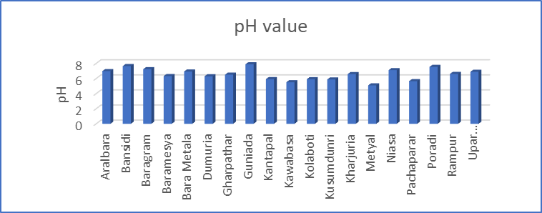.

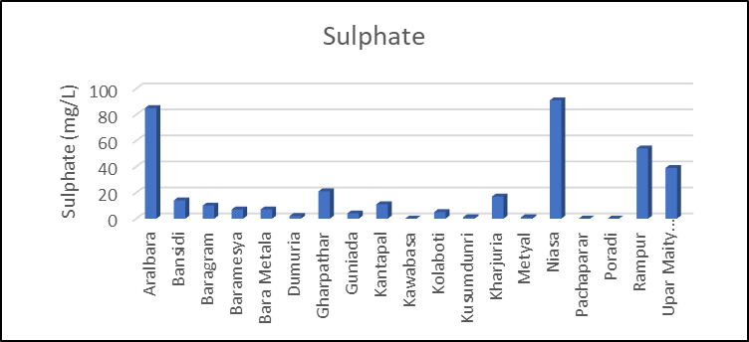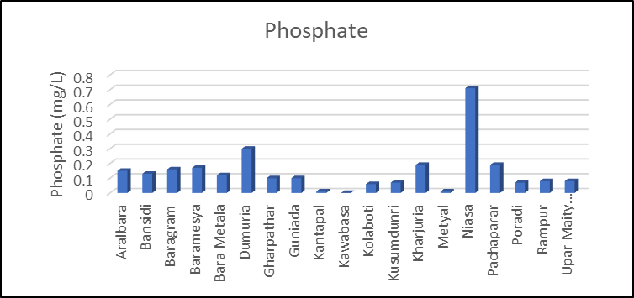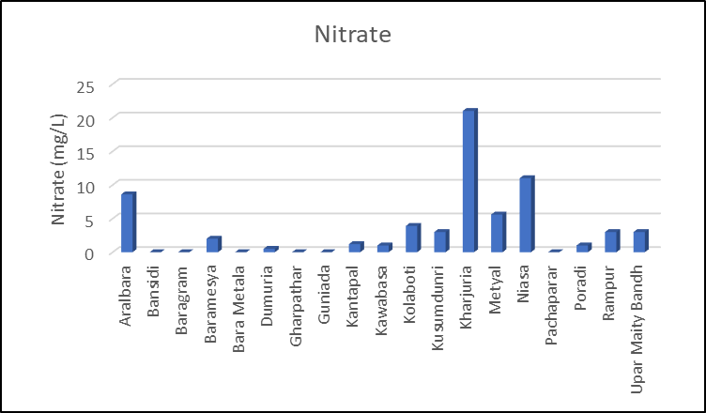

*Figure 31 Comparative Presentations of Water Quality Parameters for different sites*

**

*Figure 32 Comparative representation of WQI values of different sites*

From table 25, four classes of water quality index have been observed i.e., excellent (2 sites), good (6 sites), poor (5 sites), unfit for drinking (6 sites). The locations from where non-potable water samples have been collected were Aralbara, Baramesya, Dumuria, Kantapal, Kusumdunri and kharjuria. Among these places Kusumdunri, Aralbara and Kharjuria have moderate to good groundwater potential. But because of unacceptable water quality, artificial recharge at those locations is hardly recommended. Also, alternate sources of drinking water other than groundwater has been proposed. This combined groundwater potential and water quality study would be very much helpful for effective water resources management of this river basin.

# Chapter: Validation of the Model

Validation of proposed groundwater potential model has been carried out by Pearson’s correlation coefficient and a geophysical survey conducted in different locations of the study area. The process of validation has been mentioned in the section 5.1 and 5.2

## Validation Using Pearson’s Correlation Coefficient

Statistically, Pearson correlation coefficient or Pearson’s r is a measure of linear correlation between two sets of data. In this case, two sets of data are groundwater level below the surface in the y axis and groundwater potential index value in the x axis.

If groundwater potential index of a place increases, groundwater level below the surface would be less. So, the correlation value should have a value between 0 to -1. In this study, correlation coefficient is -0.7. So, the model is reasonably consistent.

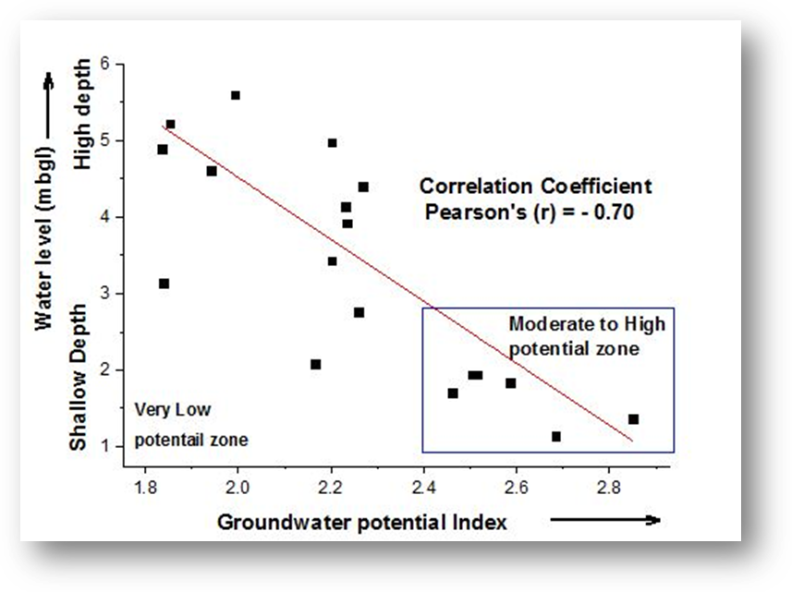

Figure 33 *Water level vs Groundwater potential Index graph*

## Validation Using VES Survey

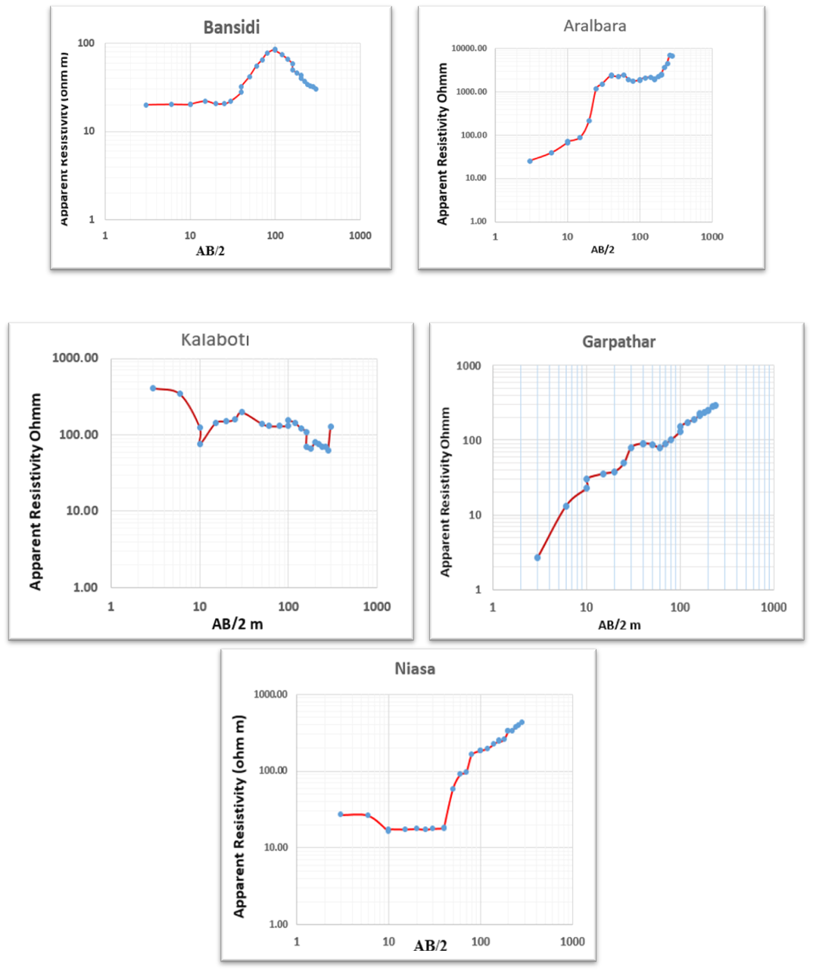Validation of the model has been done by a vertical electrical sounding survey also. VES survey has been conducted in total 5 sites of the basin. Instruments used for conducting vertical electrical sounding survey were a resistivity meter (MODEL-SSR-MP1), two potential electrodes, two current electrodes, wires and wire holders. The Survey data has been u exported to IPI2win software to execute curve matching for apparent resistivity vs half of distance between current electrodes. Finally, different geoelectrical layers have been identified from Dar-Zorruk parameters mentioned in section 2.5.1.

Figure 34 *Apparent resistivity vs half of distance between current electrodes graphs*

*Table 26 Validation of groundwater potential using Dar-Zarrouk parameters*

|  |  |  |  |  |  |
| --- | --- | --- | --- | --- | --- |
| **Site name** | **Apparent resistivity (Ohmm)** | **Thickness (m)** | **Total transverse resistance** | **Total longitudinal conductance** | **Depth (m)** |
| Garpathar | 2.85 | 0.17 | 0.5 | 0.0596 | 0.17 |
|  | 1.29 | 0.753 | 1.0 | 0.5837 | 0.953 |
|  | 4678 | 1.66 | 7765.5 | 0.0004 | 3.8 |
|  | 1520 | 1.56 | 2371.2 | 0.0010 | 18.2 |
|  | 5952 | 1.34 | 7975.7 | 0.0002 | 152 |
|  | 7083 | 4.48 | 31731.8 | 0.0006 | 60 |
|  | 7093 |  |  |  |  |
| **Sum** |  |  | 49845.7 | 0.6456 |  |
| **GPZ** |  |  | **Transmissivity** | **Protective capacity** | **Remarks** |
| Very low |  |  | Moderate | Moderate | Agree |
| **Site name** | **Apparent resistivity (Ohmm)** | **Thickness (m)** | **Total transverse resistance** | **Total longitudinal conductance** | **Depth (m)** |
| Kolaboti | 459 | 3.22 | 1478 | 0.007 | 3.22 |
|  | 24.2 | 1.31 | 32 | 0.054 | 4.53 |
|  | 140 | 80.7 | 11298 | 0.576 | 85.2 |
|  | 623.2 | 85.23 | 53115 | 0.137 |  |
|  | 8607 |  |  |  |  |
| Sum |  |  | 65923 | 0.774338 |  |
| **GPZ** |  |  | **Transmissivity** | **Protective capacity** | **Remarks** |
| Good |  |  | Good | Moderate | Agree |
| **Site name** | **Apparent resistivity (Ohmm)** | **Thickness (m)** | **Total transverse resistance** | **Total longitudinal conductance** | **Depth (m)** |
| Aralbara | 16.8 | 0.547 | 9.1896 | 0.032559524 | 0.547 |
|  | 16.8 | 0.089 | 1.4952 | 0.005297619 | 0.636 |
|  | 29.3 | 0.745 | 21.8285 | 0.025426621 | 1.38 |
|  | 29.3 | 0.03 | 0.879 | 0.001023891 | 1.14 |
|  | 1323 | 1.79 | 2368.17 | 0.001352986 | 3.2 |
|  | 147 | 1.41 | 207.27 | 0.009591837 | 4.61 |
| **Sum** | 364 |  | 2608.8 | 0.08 |  |
| **GPZ** |  |  | **Transmissivity** | **Protective capacity** | **Remarks** |
| Low |  |  | Poor | Poor | Agree |
| **Site name** | **Apparent resistivity (Ohmm)** | **Thickness (m)** | **Total transverse resistance** | **Total longitudinal conductance** | **Depth (m)** |
| Niasa | 27.9 | 5.3 | 147.87 | 0.189964158 | 5.33 |
|  | 19.4 | 2.69 | 52.186 | 0.138659794 | 7.99 |
|  | 13.6 | 0.808 | 10.9888 | 0.059411765 | 8.79 |
|  | 13.6 | 3.73 | 50.728 | 0.274264706 | 12.5 |
|  | 733 | 10.5 | 7696.5 | 0.014324693 | 23.1 |
|  | 1279 |  |  |  |  |
| **Sum** |  |  | 7958.2728 | 0.676625115 |  |
| **GPZ** |  |  | **Transmissivity** | **Protective capacity** | **Remarks** |
| Good |  |  | Moderate | Moderate | Partially agree |
|  |  |  |  |  |  |
| **Site name** | **Apparent resistivity (Ohmm)** | **Thickness (m)** | **Total transverse resistance** | **Total longitudinal conductance** | **Depth (m)** |
| Bansidi | 19.3 | 18.4 | 355.12 | 0.953367876 | 18.4 |
|  | 397 | 20.1 | 7979.7 | 0.050629723 | 38.4 |
|  | 0.72 |  |  |  |  |
| **Sum** |  |  | 8334.82 | 1.0040 |  |
| **GPZ** |  |  | **Transmissivity** | **Protective capacity** | **Remarks** |
| Good |  |  | Moderate | Moderate | Partially agree |

From the result it has been observed that, VES results of Gharpathar, Kolaboti and Aralbara gives almost same result as obtained from the model. Data obtained from Niasa and Bansidi also give satisfactory results. So, it can be concluded that the accuracy of the model is good enough.

# Chapter: Conclusions

## Overview

Application of remote sensing and GIS technique integrated with multi-criteria decision-making model is an effective and less time-consuming process to delineate the groundwater potential zone of a study area. In this study, author has been applied fourteen surface, sub-surface and field-based parameters to delineate the final map. Parameter and sub-parameter weights have been assigned using analytical hierarchy process and all the maps have been integrated in ArcGIS environment to delineate final groundwater potential zone of Silabati-Joypanda basin. The study area can be classified in five different classes based on groundwater potential index i.e., very low (1.37-2.14), low (2.14-2.44), moderate (2.44-2.72), high (2.72-3.30) and very high (3.30-4.17). 2.84%, 39.66%, 38.14%, 17.48%, 1.87% of total area of Silabati river basin are under very poor, poor, moderate, good and very good groundwater potential respectively. 60.43%, 28.87%, 9.07%and 1.63% of total area of Joypanda river basin are under very poor, poor, moderate and good groundwater potential respectively.

Validation of the model has been done by two ways: one is by statistical analysis (Pearson correlation coefficient) and another by geoelectrical method (VES survey) and both of them give satisfactory result. Water pollution risk assessment shows the proper scenario of groundwater quality of the study area. Due to the lack of funding and necessary manpower, it was very difficult to conduct VES survey throughout the basin. That’s why validation of this model has been done by two different ways to ensure the accuracy of the model. This study may be an innovative and effective tool for proper groundwater as well as water resources management of the Silabati-Joypanda basin.

## Recommendation

* Sustainable groundwater management is essential.
* Groundwater management should be integrated with surface water management, conservation, water quality, reuse, environmental stewardship, and other water management strategies. Management of groundwater should be based on existing subbasins, not on political boundaries. It is best to manage groundwater at the local and regional levels within a state-wide framework.
* A sustainable groundwater management plan must respect private property and water rights. Water quality is an essential component of groundwater management. The state plays an important role in providing technical assistance and defining oversight. There is a need for continuous, reliable state, local, and regional funding.
* The management of groundwater should be transparent and inclusive and the generated data from the study can be used by the stakeholders for sustainable management.
* In addition to public access to groundwater information, meaningful stakeholder engagement should be incorporated into groundwater management.

## Future considerations

It is crucial to investigate groundwater potential in certain areas, but further research is needed to verify its reliability with different modelling techniques. Furthermore, more studies can be conducted on the quality and suitability of the water for drinking, agriculture and industry. The potential of the groundwater resource is strongly affected by groundwater recharge. Consequently, a quantitative investigation of groundwater recharge is recommended for future study as it will provide empirical evidence of groundwater potential.

## Limitations

A major cause of the lack of accuracy is the severe discrepancy between the scale of measurement necessary to understand aquifer parameters for accurate modelling and the scale of measurement generally made under the constraints of limited time and limited budgets. Aquifer parameters should be included in a groundwater model for better efficiency. But understanding aquifer parameter is cost intensive. To facilitate the integration of other techniques with groundwater management beside these expensive techniques, alternative models and uncertainty should be explored more.

# References

1. Fashae, O. A., Tijani, M. N., Talabi, A. O., & Adedeji, O. I. (2014). Delineation of groundwater potential zones in the crystalline basement terrain of SW-Nigeria: an integrated GIS and remote sensing approach. *Applied Water Science*, *4*(1), 19-38.
2. Roy, S., Hazra, S., Chanda, A., & Das, S. (2020). Assessment of groundwater potential zones using multi-criteria decision-making technique: a micro-level case study from red and lateritic zone (RLZ) of West Bengal, India. *Sustainable Water Resources Management*, *6*(1), 1-14.
3. Nag, S. K., & Ghosh, P. (2013). Delineation of groundwater potential zone in Chhatna Block, Bankura District, West Bengal, India using remote sensing and GIS techniques. *Environmental earth sciences*, *70*(5), 2115-2127.
4. Halder, S., Roy, M. B., & Roy, P. K. (2020). Fuzzy logic algorithm based analytic hierarchy process for delineation of groundwater potential zones in complex topography. *Arabian Journal of Geosciences*, *13*(13), 1-22.
5. Mohammadi-Behzad, H. R., Charchi, A., Kalantari, N., Nejad, A. M., & Vardanjani, H. K. (2019). Delineation of groundwater potential zones using remote sensing (RS), geographical information system (GIS) and analytic hierarchy process (AHP) techniques: a case study in the Leylia–Keynow watershed, southwest of Iran. *Carbonates and Evaporites*, *34*(4), 1307-1319.
6. Chowdhury, A., Jha, M. K., Chowdary, V. M., & Mal, B. C. (2009). Integrated remote sensing and GIS‐based approach for assessing groundwater potential in West Medinipur district, West Bengal, India. *International Journal of Remote Sensing*, *30*(1), 231-250.
7. Arumaikkani, G. S., Chelliah, S., & Gopalan, M. (2017). Revelation of groundwater possible region using fuzzy logic-based GIS modeling. *International Journal of Applied Engineering Research*, *12*(22), 12176-12183.
8. Magesh, N. S., Chandrasekar, N., & Soundranayagam, J. P. (2012). Delineation of groundwater potential zones in Theni district, Tamil Nadu, using remote sensing, GIS and MIF techniques. *Geoscience frontiers*, *3*(2), 189-196.
9. Siva, G., Nasir, N., & Selvakumar, R. (2017, July). Delineation of groundwater potential zone in Sengipatti for Thanjavur district using analytical hierarchy process. In *IOP conference series: Earth and environmental science* (Vol. 80, No. 1, p. 012063). IOP Publishing.
10. Aouragh, M. H., Essahlaoui, A., El Ouali, A., El Hmaidi, A., & Kamel, S. (2017). Groundwater potential of Middle Atlas plateaus, Morocco, using fuzzy logic approach, GIS and remote sensing. *Geomatics, Natural Hazards and Risk*, *8*(2), 194-206.
11. Das, B., & Pal, S. C. (2020). Assessment of groundwater recharge and its potential zone identification in groundwater-stressed Goghat-I block of Hugli District, West Bengal, India. *Environment, Development and Sustainability*, *22*(6), 5905-5923.
12. Das, N., & Mukhopadhyay, S. (2020). Application of multi-criteria decision-making technique for the assessment of groundwater potential zones: a study on Birbhum district, West Bengal, India. *Environment, Development and Sustainability*, *22*(2), 931-955.
13. Nair, H. C., Padmalal, D., Joseph, A., & Vinod, P. G. (2017). Delineation of groundwater potential zones in river basins using geospatial tools—an example from Southern Western Ghats, Kerala, India. *Journal of Geovisualization and Spatial Analysis*, *1*(1), 1-16.
14. Agarwal, E., Agarwal, R., Garg, R. D., & Garg, P. K. (2013). Delineation of groundwater potential zone: an AHP/ANP approach. *Journal of earth system science*, *122*(3), 887-898.
15. Chowdhury, A., Jha, M. K., Chowdary, V. M., & Mal, B. C. (2009). Integrated remote sensing and GIS‐based approach for assessing groundwater potential in West Medinipur district, West Bengal, India. *International Journal of Remote Sensing*, *30*(1), 231-250.
16. Pomposiello, C., Dapeña, C., Favetto, A., & Boujon, P. (2012). Application of geophysical methods to waste disposal studies. *Municipal and Industrial Waste Disposal*, *242*.
17. Okonkwo, A. C., & Ugwu, G. Z. (2015). Determination of Dar-zarrouk parameters for prediction of Aquifer protective capacity: A case of Agbani Sandstone Aquifer, Enugu State, Southeastern Nigeria. *International Research Journal of Geology and Mining*, *5*(2), 12-19.
18. Umar, E. P. (2018, February). Identification of subsurface layer with Wenner-Schlumberger arrays configuration geoelectrical method. In *IOP Conference Series: Earth and Environmental Science* (Vol. 118, No. 1, p. 012006). IOP Publishing.
19. IS: 2720 (Part III/Sec 1)-1980; Indian Standard methods of test for soils part iii determination of specific gravity.
20. IS: 1498-1970 Indian Standard classification and identification of soils for general engineering purposes.
21. IS: 10500-2012 Indian Standard drinking water- specification.
22. C. Venkatramaiah. Geotechnical engineering. Fourth revised edition. New age international publishers.
23. V.N.S. Murthy. Textbook of soil mechanics and foundation engineering. Cbs publishers & distributors pvt. Ltd.
24. David A. Chin. Water-Resources Engineering. Third Edition. Pearson Education.